CEFIC/ ECTA Guidelines
Safe storage and handling of containers carrying dangerous goods and hazardous substances
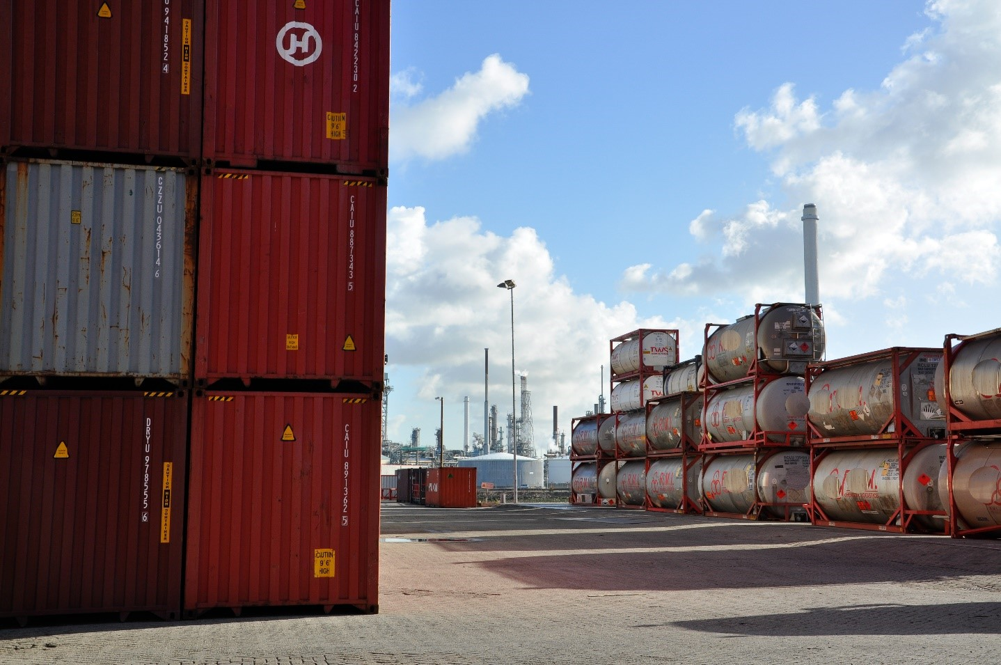

Issue 1 - March 2018

Content

1. Introduction 6
2. General Site Operations 8
2.1. General Requirements 8
2.2. Site Access 9
2.3. Registration of a Product on Site and Entrance Check 9
2.3.1. Reviewing a Storage Request 9
2.3.2. Entrance Check 11
2.4. Marking and Labeling 13
2.5. Working Conditions 13
2.6. Housekeeping 14
2.7. Management of Change 15
2.8. Competencies and Training 16
2.9. Human Behavior and Behavioral Based Safety (BBS) 17
3. Storing of Containers 18
3.1. Segregation 18
3.1.1. Basic Principles and Recommendations 18
3.1.2. Recommendations on Segregation 19
3.1.3. Tank Container 24
3.1.4. Box Containers 25
3.1.5. Measures for Segregation 25
3.2. Container Stacking 26
3.3. Flooring 30
4. Equipment 31
4.1. Equipment Selection and Specification 31
4.1.1. Moving Equipment 31
4.1.1.1. Terminal Tractors and Tractor-Trailer 31
4.1.1.2. Chassis 32
4.1.1.3. Other Vehicles 32
4.1.2. Lifting Equipment 32
4.1.2.1. Mobile Lifting Equipment 32
4.1.2.2. Cranes 34
4.2. Inspection and Maintenance of Equipment 34
4.2.1. Pre-Start Checks 35
4.2.2. Periodic Inspection 35
5. Container Operations 35
5.1. Internal Transport and On-Site Traffic 35
5.1.1. Layout of Traffic Ways 35
5.1.2. On-Site Traffic Regulations 36
5.2. Safe Handling 37
5.2.1. Loading, Unloading and Lifting Operations 37
5.2.2. Qualification of Personnel 38
5.2.3. Unattended Machinery 38
5.2.4. Safe Coupling and Uncoupling of Equipment 39
5.3. Inspection and Maintenance of Containers 39
5.4. Heating of Containers 40
5.4.1. Product Evaluation 41
5.4.2. Control of Steam/ Water/ Glycol Pressure 41
5.4.3. Glycol/ Water Temperature 41
5.4.4. Product Temperature 41
5.4.5. Overflow 42
5.4.6. Heating Plan 42
5.5. Sample Taking 42
5.6. Transferring Material into another Container 43
6. Emergency Response & Spill Preparedness 45
6.1. Spills 45
6.1.1. Small Spills - Dripping 46
6.1.2. Large Spills 47
6.2. Exposure of People 47
6.3. Fire and Explosion 48
6.4. Natural Disasters/ Climatological and Geographical Risks 50
6.4.1. Temperature 50
6.4.2. Flooding and Heavy Rain 51
7. Abbreviations 52
APPENDICES 53
Appendix 1 - Model Container Terminal Risk Assessment 53
Appendix 2 - Container Segregation - Additional Information 53
Appendix 3 - CEFIC/ ECTA HSSE Self-Assessment for Container Storage 54
Appendix 4 - Pre-Start Checklist for the inspection of Trucks used onsite. 54

Figures
Figure 1 - Overview of typical elements of a HSE-MS and a selection of procedures that would be expected to be in the Planning & Procedures section for a container storage terminal 8
Figure 2 - Flowchart: Product Registration 12
Figure 3 - Tank containers (front) and box containers (back) 25
Figure 4 - swap body (top) and 20’ tank container Figure 5 - 40’ tank container 26
Figure 6 - Stacking of 20’tank containers (left), swap bodies (right) and block stacking of empty box containers (in the back) 28
Figure 7 - Schematic representation of a stair stacking of containers that should be more stable in high wind speed situations 28
Figure 8 - Swap body tank containers are sometimes of such a design that it takes some skill and careful maneuvering to place the containers well on top of each other 29
Figure 9 - Containers on a liquid tight floor 30
Figure 10 - Terminal tractor 31
Figure 11 - Empty handler 33
Figure 12 - Reach stacker (for loaded containers) 33
Figure 13 - Rail mounted gantry crane (RMG) 34
Figure 14 - Containers connected to a heating unit 40
Figure 15 - Pump, running on diesel (no sparks), for chemical liquids 44
Figure 16 - Movable drip tray 46

Tables
Table 1 - Guidance on working conditions at a container terminal 14
Table 2 - Overview and examples of typical changes 15
Table 3 - Typical Management of Change (MOC) process⁶ 16
Table 4 - Unintentional errors and their follow-up 17
Table 5 - Types of rule breaking and corrective actions 18
Table 6 - Recommended container segregation based on Product Hazard Phrases or ADR class and a Priority figure 21
Table 7 - Guidance on maximum container stacking height for ISO Containers depending on whether empty or loaded and wind speed 27
Table 8 - Guidance on maximum container stacking height for Swap Body Containers depending on whether empty or loaded and wind speed 27
Table 9 - Overview of typical traffic signs on a container terminal 36

Disclaimer
This document is intended for information only and sets out best practice guidelines for managing safe storage and handling of containers carrying dangerous goods and hazardous substances. The information provided in these guidelines is provided in good faith and, while it is accurate as far as the authors are aware, no representations or warranties are made with regards its completeness. It is not intended to be a comprehensive guide. Each company, based on their individual decision making process, may apply these guidelines, in full or partly or apply any other adapted measures.
No responsibility will be assumed by ECTA/Cefic in relation to the information contained in these Guidelines.

Introduction
A significant part of the transport of chemicals in Europe occurs in intermodal transport units (ITUs), e.g. iso-containers, and makes use of the intermodal infrastructure in place. This transport mode can contribute up to 60% of the total transport volume. Whereas currently the majority of the transport volume is based in Western Europe, this Cefic report¹ indicates potential for increasing volumes into, in particular, Russia and South-East Europe. Container terminals for short-term storage of ITUs, but also longer-term storage of preloaded ITUs, are a key part in the intermodal transport infrastructure for ITU transport. Next to a few (very) large hubs, a significant part of the container flow is handled through small and medium sized container storage terminals.
While large explosions such as those in 2015 at Tianjin China (173 fatalities, 8 missing and about 800 people injured) are fortunately an exception, smaller scale incidents happen regularly. Indicative of the situation at container terminals is a 2013 analysis by TT Club, provider of insurance and related risk management services to the international transport and logistics industry. The analysis of 9500 claims valued at US$ 400m associated with container terminals showed that “the majority (68%) were due to poor operations and processes and a further 14% resulted from maintenance related issues. Only 18% were caused by weather related issues, seemingly out of the control of the operator, but an amount of these could have been avoided through more adequate preparation”. The main area of risk appeared to be in the operation of mobile equipment such as quay cranes, lift trucks, rubber‐tyred gantry cranes and straddle carriers. ITUs containing dangerous goods and hazardous substances bring a further significant risk dimension to the storage of containers.
Whereas the storage of packed dangerous goods up to 1000kg (e.g. IBCs) in warehouses and bulk liquids in fixed shore tanks is frequently well regulated, the storage of ITUs is often less well regulated. In member states of the European Union, the container terminals exceeding certain storage quantities will need to meet the Seveso III Directive on the control of major accidents. The Directive requires:
- The notification to the authorities of a new site.
- A Major-Accident Prevention Policy (MAPP).
- Implement MAPP through a Safety Management System including a Risk Assessment.
- For so-called upper-tier sites, a Safety Report has to be produced every 5 years. An upper-tier site is a site that contains more than a specified amount of certain dangerous goods.
- The management of change.
- An Emergency Plan for upper-tier sites.
- The need to inform the public.
- An incident notification/ registration.
While the storage of packed goods is in most EU countries well described in regulations, it appears that the storage of ITUs is only very limitedly addressed. Examples are the Technical Rules for Hazardous Substances - Storage of Hazardous Substances in Nonstationary Containers (TRGS 510) in Germany and a short section on iso-containers storage in the Dutch PGS 15 - Storage of Packed Dangerous Goods.
While taking into account the above regulatory landscape, this CEFIC/ ECTA Guideline will provide guidance on the safe storage of ITUs based on:
- a risk assessment of the storage of ITUs on container terminals,
- best practices from the companies contributing to this Guideline and
- the existing regulations.

When local or international regulations set more stringent requirements than the guidance in this Guideline, those regulations prevail.
The scope of this Guideline is the safe (intermediate) open-air storage and handling of hazardous and non-hazardous goods in tank- and box container at small and medium sized container terminals. The handling includes among others, placing into and releasing from storage, transport inside the terminal, sampling, heating/ cooling and transferring product from container to container.
Not in scope are the large deep-sea marine shipment container terminals. Nor is the storage of:
- Explosive products and substances (GHS Symbol 01; H200-H205)
- Ammonia nitrate and ammonium nitrate containing formulations (Weight percent > 10%)
- Organic Peroxides and formulations of these, unless they contain less than:
  - 5 % of organic peroxides or
  - 0,5 % active oxygen from organic peroxides and additionally the weight percent of hydrogen peroxides is below 5%
- Radioactive substances
- Hazardous substances with the danger of infection.

The guidance provided in this Guideline is based on an assessment of the typical risks present in a small-medium sized container storage terminal and best practices from the companies that contributed to this Guideline. The Model Container Terminal Risk Assessment can be found in Appendix 1 and might form the starting point of a risk assessment of a specific terminal. In that case, it should always be reviewed in detail to take into account local circumstances, chemicals stored and local processes.
Section 2 focusses on the general operations at a container terminal including site access for people, equipment and containers. Section 3 provides guidance on the storage of containers including container segregation and stacking. Equipment and its inspection and maintenance is addressed in Section 4, while Section 5 is looking deeper into the handling of containers e.g. in moving, lifting and heating. The last section provides guidance on when operations go wrong and an emergency situation occurs.
A (self)-assessment form provided in Appendix 3 will allow terminal management and potential customers to assess the current situation at a terminal against the guidance and best practices in this Guideline.

General Site Operations

General Requirements
Experience learns that a safe site runs efficiently. Basically, in order to work safely certain performance standards, processes, work planning and execution and control on changes to these, should be in place. Establishing these structures will also ensure that the basic work process runs efficiently. This can be achieved by means of an effective HSE Management System, which is named Safety Management System in the Seveso regulation. Figure 1 gives an overview of the generic elements of an HSE Management System in the context of a container terminal. Some of these HSE elements will be addressed in more depth in the subsequent section.
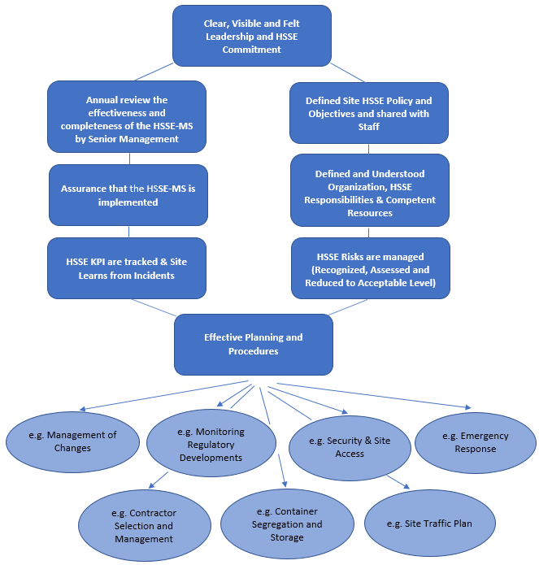
Figure 1 - Overview of typical elements of a HSE-MS and a selection of procedures that would be expected to be in the Planning & Procedures section for a container storage terminal

Site Access
The access to the site should be limited to those people and products that need to be. This, among others, to avoid that theft and/or tampering with containers and equipment can take place. Moreover, this also will reduce the chance that someone enters an area were the person should not be in and be exposed to moving equipment or hazardous product without the correct PPE. Unlawful entrance to the site should be prevented, e.g. using a fence. A documented entrance check should take place on all people (staff, contractors, drivers, visitors), transport documentation (including ADR certificate and driver ID) and product before site entrance is allowed. Drivers and any other visitors should receive instruction on site rules including PPE to use, how/where to deliver the container and what to do in case of an emergency. Equipment should be checked (including leakages) before it enters the site or immediately afterwards. Equipment that does not meet regulations, site requirements or is leaking should be dealt with according to site procedure.
Visitors that will enter the site on foot should be given clear instructions on the lay out of the terminal and where they can go and where not. They should be given guidance on PPE’s to wear and how to behave in a safe way. One of the instructions should be to always be aware of location of moving vehicles by monitoring the sound and by making eye contact with the drivers, where ever pedestrians and moving equipment may cross their path.
The next section will provide further guidance on, among others, the entrance check for product and equipment.

Registration of a Product on Site and Entrance Check

Reviewing a Storage Request
Before a new storage agreement can be closed, a proper management of change (MOC) should have taken place (see also section 2.7 below) in which it is determined whether the product can be stored and handled safely on site and within the permit. (See also Figure 2 - Flowchart: Product Registration)
To be able to do the assessment of the new storage request (Storage Request Check) from a product hazard and legal perspective the following information would be needed from the customer:
- SDS (preferably local language(s) of storage(s) and/or English)
- Product name
- Chemical product name
- GHS/CLP classification
- UN number/ CAS number
- Proper Shipping Name
- Classification (+ subsidiary risk)
- Packing group
- Flash point
- Boiling point
- Weight
- Suitable Personal Protective Equipment (PPE)
- Suitable extinguishing media (water/ foam/ etc.)
- Type of shipping unit
- Customer name
Based on the above information it is recommended to consider (among others) the following questions to evaluate whether the storage request can be accepted and the subsequent further processing of the unit at the terminal can be executed.

Chemical properties:
- Poisonous substance?
- Flammable substance?
- Does it represent a hazard when in contact with extinguishing agent?
- Specific requirements regarding PPE in case of a Loss of Containment (LOC)?
- Present PPE sufficient?
- Current means of spill control sufficient?
Storage considerations:
- Presence of substance allowed according to permit?
- Limitations in volume according to permit?
- Modification generating change in permit, notification to authorities required?
- Logistical modifications needed? (entry- and exit road, transport, stacking area)?
- Additional separation rules necessary for safe storage?
- Negative health effects in case of exposure?
Procedures and training:
- Additional controls necessary at entry?
- Modifications to current procedures and/or instructions?
- Extra training/ instruction needed?
- Is there a need for creating an additional risk scenario?
Repressive services:
- Are the present extinguishing means sufficient and suitable in case of an emergency (fire or LOC)?
- Is there the possibility of a reaction in case of contact with the extinguishing means?
- Are the present means of spill control sufficient in case of a LOC?
- Emergency plan to be adjusted?
Heating/ Cooling:
- Heating/ cooling of the product allowed?
- Desired product temperature?
- Can the required method of cooling/ heating be applied?
Transferring product into another receptacle:
- Is it allowed to transfer the product?

The site should have a structured process in place to handle this assessment and predefined roles who are authorized to approve such storage and handling requests (e.g. Director, Site Manager) and who should be consulted in the process (e.g. HSE Manager, Dangerous Goods Safety Advisor DGSA).
The storage location to be selected must be suitable for the products to be stored according to the product characteristics and site segregation rules (see section 3.1).

Entrance Check
Intermodal transport units (ITUs) need to be registered with their storage location upon arrival. For terminals that underlie Seveso III Directive this is a legal requirement, and best practice for all other terminals as a prompt registration is key for an effective emergency response.
When the container arrives at the terminal, it must be first checked whether the ITU and product is registered in the terminal (IT-)system and whether an order for storage exists. If this is not the case, the container should not be allowed to progress until the situation is resolved and it is ensured that the review as described under 2.3.1 is completed. The site (IT-)system should contain all relevant information for handling of the transport unit. Subsequently a visual check will need to be done. The visual check should contain both a technical and formal check:

- Visual technical check of the handling unit conditions on/of:
  - leakage (leaking unit)
  - visual deformations of the transport unit
  - pressure (depressurized)
  - temperature (if necessary)
  - used container type
- Visual formal check of the handling unit conditions on/of:
  - container state (loaded/ unloaded/ cleaned)
  - properly labeled and marked according to legislation/ regulations (ADR/ IMDG) (see section 2.4)
  - seals
  - seal number
  - Container number
  - CSC/ ACEP/ ITCO
  - Driver documents

Only if the checks are in line with site rules and expectations the ITU should be allowed on site.

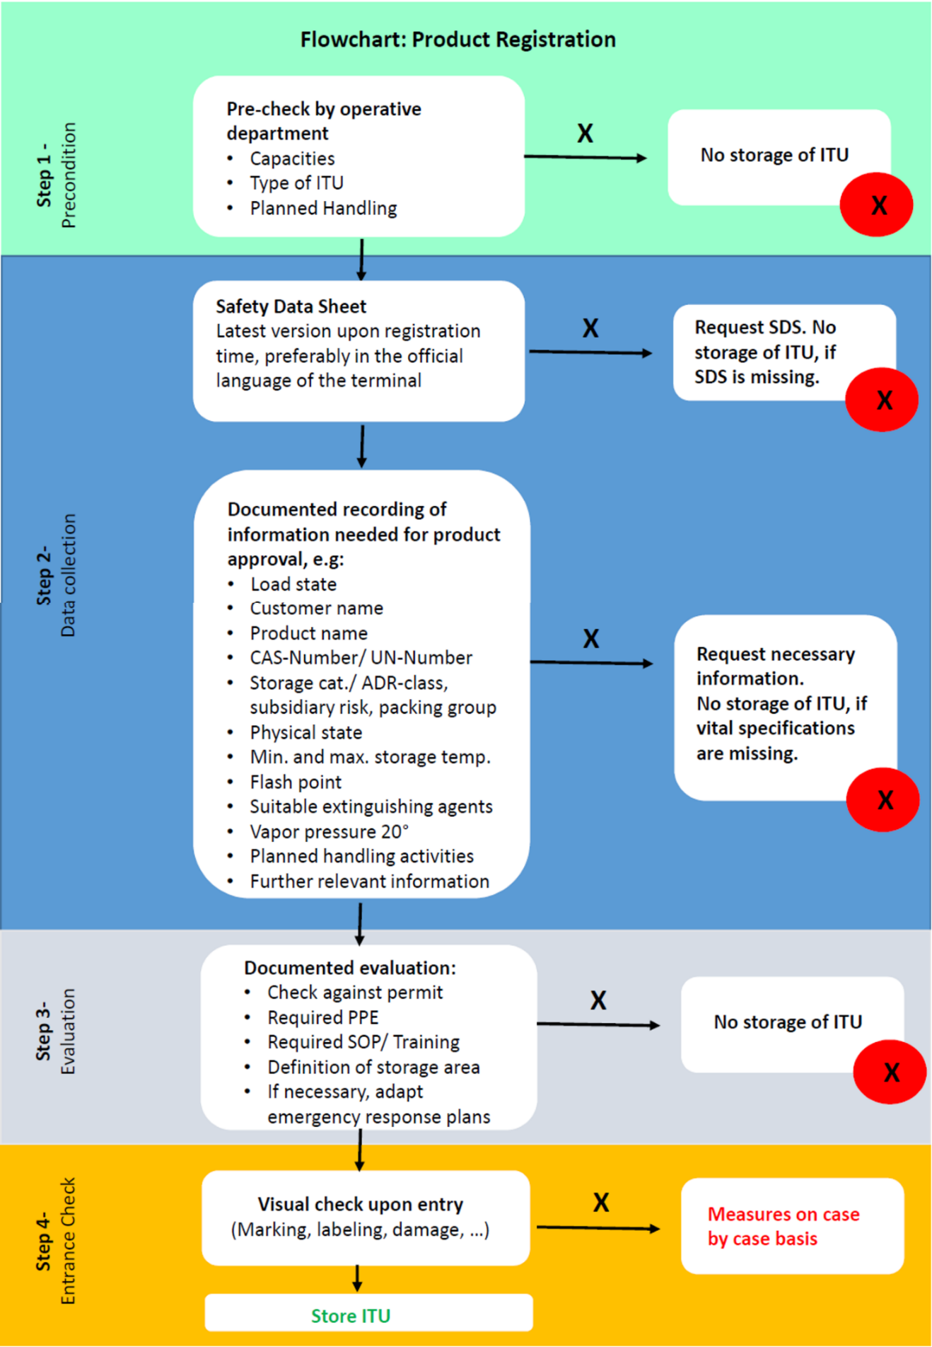
Figure 2 - Flowchart: Product Registration

Marking and Labeling
Special attention should be paid to Marking and Labeling during the entrance check, in order to prevent typical errors, which are placards, marks or labels that are:
- not visible
- wrongly placed
- damaged
- missing
- incomplete
- incorrect*.
In case of an incident the consequences of poor marking and labelling can be
- exposure to dangerous (reaction) product(s) due to wrong separation.
- injuries or even fatalities due to unknowingly fumigated containers.
- delays because of misconceptions.
- costs of correcting the placards.

(*) Be aware of unknown or misdeclared dangerous goods. There could be a mismatch between the content of a container and the safety data sheet. This could lead to wrong emergency procedures resulting in catastrophic events.

Working Conditions
Working conditions are an important aspect for the quality of work and the relationship between the staff and management. The working conditions cover a large range of topics e.g. physical conditions and mental demands that exists in the workplace.
Working on container terminals is always bound to strict safety rules. Working with or nearby cranes, reach-stackers or forklifts has specific risks that must be carefully and specifically handled.
To get and maintain transparency in the working conditions a risk assessment should be part of the management of change process (see section 2.7) that should take place before starting new on-site terminal activities. Risk assessments should be renewed on regular basis or after a change. The Model Container Terminal Risk Assessment in Appendix 1 also addresses several risks that are associated with working conditions and can therefore be used as a starting point. Additionally, Table 1 displays further considerations that are relevant to working conditions too. It should be noted that this table should not be considered as an exhaustive list of all risks or activities on intermodal/ storage terminals and should be adapted for the local conditions.
Various of these areas of attention will be further addressed in the next sections.

Table 1 - Guidance on working conditions at a container terminal
Working Condition | Guidance
Maintenance | All equipment (e.g. Reach Stacker, cranes) should be maintained according to the legal regulations, manufacturer’s instructions and according to the signs of wear and tear.
Lighting | The lighting conditions should be sufficiently designed according to the circumstances.
Traffic | The traffic and the traffic routes on the terminal should be clearly regulated in order to avoid accidents.
PPE | The personal protective equipment should be selected according to the products or substances to be stored and the work executed.
Falls | Sufficient and appropriate measures should be taken to prevent persons falling or being hit by falling objects.
Climatic conditions | All workstations (Reach Stacker, forklift, etc.) should be air-conditioned according to the temperature and the climatic conditions.  Use proper clothing while moving between areas of different temperatures.
Shift working times | Ensure that normal industry standards in shift hours are respected.
Musculoskeletal issues | Limit exposure time on heavy machinery.
Cleanliness | The workplaces and resources used should be kept clean.

Housekeeping
Good housekeeping practices are an important part of general operations because they can reduce workplace hazards resulting in a safer and better job. Poor housekeeping practices on the other hand, can have severe consequences for example resulting in
- an obstructed view on safety equipment and signs,
- equipment damage or slipping and tripping accidents due to objects left lying around,
- as well as contamination of working devices and staff members.

The most probable consequences are easy to prevent. Employees should be responsible for cleaning up small spills during normal execution of work, while being mindful of the nature of the product. It is important to implement a duty to report, use maintenance and cleaning protocols. For critical situations, an emergency procedure is necessary, medical assistance, neighborhood communication and a fire brigade has to be in place (see section 6).
To forestall tripping and slipping, workplaces should never be cluttered, giving workers enough space to move. General waste as well as damaged parts such as broken pallets are to be properly disposed.
It is important to store flammable, quick-burning materials (e.g. pallets) in designated locations away from ignition sources. Additionally, it has to be regarded that the storage of pallets does not heighten the fire load of buildings, e.g. by stacking them up against walls.
All safety devices such as fire extinguishers or safety showers as well as road signs and floor signaling must remain visible at all times.

Management of Change
As described in the CEFIC/ ECTA Guideline on Managing Change in a Chemicals Supply Chain, investigations into some of the major incidents in the Chemical Industry and Supply Chain identified a lack of proper Management of Change (MOC) as one of the root causes of those incidents. In most cases, it is either not recognized that something critical is being changed or the impact of the change is not understood. Typical changes are:

Table 2 - Overview and examples of typical changes
 | Typical Changes | Examples
a | Changes to any type of technology, equipment or physical asset | New lifting equipment  New PPE  New Emergency Response Equipment  New product on site  Changes in traffic flow
b | Changes to procedures, policies, standards, etc. | New heating procedure  New entrance check  New permit  New stacking requirements
c | Changes to a work process | Modification work instruction on heating  Change in instructions at the gate  Changes in inspection rounds
d | Changes to people's roles or responsibilities | New advisor on dangerous goods  Someone becoming team lead  New contractor

The terminal should have a process in place that structurally reviews these changes, assesses the risks associated with the change and define the corrective actions to mitigate the new risks. The MOC process typically has the following 6 formal steps and the people that have role in it. The formal review steps by the person who ultimately is accountable means that the right level of overview is brought in, including the challenge, and that this person formally accepts all the risk associated with the change.

Table 3 - Typical Management of Change (MOC) process⁶
 | MOC Process Step | Who
1 | Identify and describe the Change, including a proposal and justification | The Change Requestor
2 | Authorization for developing the scope of the change and assigning a MOC Team to do the development | Director/ Terminal Manager
3 | Development of the scope with the risk assessment and mitigating action definition as key component | MOC Team (e.g. Project Lead, SMEs and HSE)
4 | Review and approval for implementation | Director/ Terminal Manager
5 | Implementation | MOC Team
6 | Acceptance of implementation and check that all risk mitigating actions have been implemented | Director/ Terminal Manager

The CEFIC/ ECTA Guideline on Managing Change in a Chemicals Supply Chain contains a tool to handle a change in a structural manner.

Competencies and Training
Having people with the right competencies is crucial for a safe and efficient operation on the terminal. Therefore, the competencies required for each role on the terminal should be defined including applicable regulatory requirements. In addition, a training plan should be designed that clarifies by when someone new to the role should have received which training and when a person in that role should be retrained. Training should be provided by people that are competent on both the subject and in training people. The progress of the training plan should be checked regularly by the Terminal Manager. Similarly, the competencies of contractors on site should be defined and used as key contractor selection criteria. If necessary a contractor training plan should be in place to address gaps. Given the HSSE risk involved, special attention should be given to the roles of drivers of mobile and lifting equipment, dangerous goods advisors, emergency response staff, HSSE staff, staff doing the entrance checks, inspectors, staff working in heating stations and supervisors, etc. The role of the supervisor should not be underestimated. This person is a key determining factor in the HSSE culture of staff. Therefore, given that these people are mostly promoted based on their technical skills, special attention should be payed to his/her engagement/ coaching skills and his/her understanding of HSSE risks and how to manage these. The site should provide easy readable work instructions for all activities on site as also described in the next section.
Before starting a new job on regular basis, the complete staff should make a safety and security training according to dangerous goods legislation (e.g. ADR).

Human Behavior and Behavioral Based Safety (BBS)
While substitution by technical or organizational measures is the preferred corrective action for human error, people keep on having an important role at an operational site. Consequently, investigations still show that wrong human behavior and human errors belong to the key root causes of incidents. Examples are staff and contractors who make unintentionally errors or knowingly do not adhere to rules and standards (e.g. use of proper PPE and work instructions). Whereas an unintentional error can be addressed by coaching and training (see Table 4), knowingly not following rules and standards needs a deeper understanding on the why. Is the person not able to follow defined rules/ standards, does a culture of noncompliance exist in the team/ at the location or is he/she trying to create a benefit from the noncompliance? As described in Table 5 each of these situations require a different follow-up.

Table 4 - Unintentional errors and their follow-up
Unintentional error type | Description | Corrective action
Slip | Small error e.g. pressed wrong button | Coaching conversation by supervisor
Lapse | Forgot as an exception something to do e.g. a simple check. Might be due to a distraction | Coaching conversation by supervisor
Mistake | An error because of a lack of competence | (Re-)train and review competence definition and training program

The combination of rule violation and an error is often leading to a disaster. One of the most important barriers to prevent this from happening is visible and felt leadership. Senior management should set clear standards and visible drive and adhere to these. Senior managers should regularly be on the work floor to see what is happening, interact with staff, listen and learn from them where potential issues are and follow up on these learnings. At the same time, they can engage on the (HSSE) standards and let staff feel why these are important to him/her.
By creating a no blame and open work culture in which staff feels comfortable to share their unease about procedures and rules, and management listens actively to weak signals on unsafe situations, a continuous improvement process on procedures/ rules can take place before an incident happens. Updates to these procedures should be handled through the Management of Change process (see Section 2.7). Toolboxes are an excellent place for leadership to interact with staff to strengthen the messaging and foster an open, no blame culture. Knowingly noncompliance should be unacceptable and corrective actions should be taken, not only towards the noncompliant staff but also the role of the supervisor should be reviewed. Violation plus error leads to disaster
Rule violations that people knowingly perform and that might result in severe consequence, e.g. fatalities, require special attention and should not be acceptable for site management. A proven successful approach, as part of visible and felt leadership, is setting a limited number of rules, in this space, that will have the ultimate consequence for staff and contractors if they do not adhere to. These rules are known in Industry as for example Life Saving Rules, Cardinal Rules or Golden Rules. Before the rules are brought in place, they should be well communicated to staff, contractors and visitors and the consequence of not following these rules should be clear to all. In case a culture of rule violation exists in an area, management should not only look to the rule breakers but also to the role the supervisor had in allowing this culture to develop.

Table 5 - Types of rule breaking and corrective actions
Rule breaking type | Description | Corrective action
Unintentional -  Lack of understanding | Procedure/ rule is poorly written or too complex to understand | Rewrite procedure and test with staff
Unintentional -  Lack of awareness | Lack of training or information not readily available for staff | Review training and communications program
Routinely on site (1) | Unnecessary procedure/ rule | Eliminate procedure/ rule
Routinely on site (2) | Poor attitude to compliance/ Poor supervision | Enforce compliance/ Correct (train) supervision
Situational | Lack of resources to be able to follow procedure/ rule | Make resources available or, if possible, simplify procedure/ rule
Optimizing (1) | Ineffective procedure/ rule | Improve/ simplify procedure
Optimizing (2) | Personal convenience | Enforce compliance and corrective action to person.

Storing of Containers

Segregation
Given the large variation in products that might be stored at a container terminal, only some high-level guidance on segregation of the most common products can be given. Please ensure that advice is obtained on any segregation plan from a competent internal or external expert e.g. the dangerous goods safety advisor before implementing the plan and any modification to it. The expert should take into account the hazards of the product, as for example described in the relevant SDSs, and applicable legal requirements. Additional to the own expertise and/or the input of the dangerous goods safety advisor, the local emergency response provider should be consulted. Various computer programs exist that could facilitate the development of a segregation plan. The final segregation plan should always meet at least the (local) regulations and requirements put down in the permit.

Basic Principles and Recommendations
Product segregation is indispensable to reduce the risk of hazardous interaction between different products in the case of a spill (e.g. due to a leak or a fire). But in the case of tank container or box container depots there is a reduced risk of interaction between the goods in comparison to packaged good in warehouses. Consequently, the requirements for segregation in container storage are less severe than for warehouses.
Nevertheless, interaction between the stored goods, creating a hazardous situation, should be taken into account. Therefore, the following fundamental rules should be considered. In addition, the detailed recommendations on segregation in general (3.1.2), and for tank- and box-container specifically (3.1.3 and 3.1.4), should be reviewed too.

- Hazardous goods should be segregated if the risk will increase significantly in the case of interaction of the stored products.
The risk increases significantly when one of the following can occur:
  - Reactions forming (high) flammable gases
  - Reactions forming toxic gases
  - Reactions among the stored products resulting in a fire
  - Heavy exothermic reactions
  - Violent decomposition.
Concrete examples are:
    - Cyanides and acids react and produce cyan-hydrogen
    - Sulfides and acids react and produce hydrogen-sulfide
    - Strong oxidizing products and organic products
    - Other products with Hazard Statements EUH029, EUH031 and EUH032 (GHS-Hazard Statements)
- Products should not be stored together if special information from authorities or the producers indicate so.
- Products should be segregated if different extinguishing agents are needed because of the possibility of a hazardous interaction of the product and the extinguishing agent.
Examples are reactions of:
    - alkali metals with water or foam leads to explosive chemical reactions.
    - phosphor-trichloride with water producing hydrogen chloride.
    - Special products with EUH014, EUH029 (GHS-Hazard Statements)

In the case that there is not sufficient experience on site on the interaction of products and segregation, an external expert or suitable computer programs for storage administration could be a solution.

Recommendations on Segregation
To determine the segregation the products and substances are classified in storage classes. Such classification is derived, in particular, from information in the safety data sheet, labels specific to the hazardous substance or labels according to dangerous goods legislation. Based on this information the classification can, for example, be done according to the hazard phrases approach as developed in the German “Technical Rules for Hazardous Substances - Storage of hazardous substances in nonstationary containers”⁴ (TRGS 510 Jan 2013) (see the first column of Table 6 below). In the case of hazardous substances that are not labeled as dangerous, information from the supplier or knowledge obtained from practical experience can be used.
Hazardous substances are grouped into a storage class if their hazard indicators are considered to be similar and therefore require similar protective measures. In case of labelling under the dangerous goods legislation, both the primary hazard and the subsidiary hazards must be taken into account.
The first column in Table 6 lists the H-Phrases that define the storage class of the product as presented in column three. If a product has more than one relevant H-Phrase leading to different Storage Classes (SC), the second column shows the priority in SC on which recommendation about segregation should be preferred. The fourth column specifies the recommendations about product segregation. The storage classes specified in this column should be segregated from the product class in column three.
In the case there is a recommendation about storage segregation and there is still a need to store these products next to each other because of local circumstances, section 3.1.5 shows examples for suitable measures.
Additional information about the usage and definition of the storage classes can be found in Appendix 2.

Table 6 - Recommended container segregation based on Product Hazard Phrases or ADR class and a Priority figure
Product Hazard Phrase or ADR/ UN Class/ Other | Priorityª | Storage Class (SC) ^{b} | Recommended to segregate from Storage Classes (SC) ^{c}
H200 to H205, H240, H241 or ADR 1 | 1 | SC 1 - Explosives | Out of Scope from this Guideline
H220, H221, H270, H280; H281 or ADR 2 or UN 1051; UN 1052 | 5 | SC 2A - Gases | 3, 4.1B, 4.2, 4.3, 5.1A, 5.1B, 6.1A, 6.1B, 6.1C, 6,1D, 10
H222, H223 or UN 1950, UN 1057 | 4 | SC 2B - Aerosol packages | 3, 4.1B, 4.2, 4.3, 5.1A, 5.1B
H224 to H226 or ADR 3 or R10, R11, R12 | 14 | SC 3 - Flammable liquids | 2A, 2B, 4.1B, 4.2, 4.3, 5.1A, 5.1B, 6.1B
H240, H241 or ADR 4.1 (Storage groups I to III) | 6 | SC 4.1A - Other Explosive substances | Out of Scope from this Guideline
H228 ADR 4.1 or Solids with R11 | 10 | SC 4.1B - Flammable solids or desensitizing explosive substances | 2A, 2B, 3, 5.1A, 5.1B, 6.1A, 6.1B - For 6.1A combined storage can be considered when an automatic fire extinguishing system is in place ^{b)}
H250 to H252 or ADR 4.2 or R17 | 8 | SC 4.2 - Pyrophoric or self-igniting substances | 2A, 2B, 3, 5.1A, 5.1B, 6.1A, 6.1B
H260, H621 or ADR 4.3 or R15 | 9 | SC4.3 - Substances which, in contact with water, emit oxidizing gases | 2A, 2B, 3, 5.1A, 5.1B, 6.1A, 6.1B
H271 or ADR 5.1 of packaging group I or Listed in Annex 6 | 12 | SC 5.1A - Strongly oxidizing substances | 2A, 2B, 3, 4.1B, 4.2, 4.3, 6.1A, 6.1B, 6.1C, 6,1D, 8A, 8B, 10, 11,
H272 or ADR 5.1 of packaging group II or II | 13 | SC 5.1B - Oxidizing substances | 2A, 2B, 3, 4.1B, 4.2, 4.3, 6.1A, 6.1B, 8A, 10, 11 - For 6.1A, 6.1B, 8A, 10, 11 combined storage can be considered when an automatic fire extinguishing system is in place ^{b)}
UN 1942, UN 2067, UN2071, UN 3375 or TRGS 511 Groups A to C | 11 | SC 5.1C - Ammonium nitrate or mixtures containing ammonium nitrate | Out of Scope from this Guideline
H242 or ADR 5.2 or BGV B4 Risk Group OP1 to OP4 | 7 | SC 5.2 - Organic Peroxides or self-reactive | Out of Scope from this Guideline
H300, H310, H330 or ADR 6.1 of packing group I or II | 15 | SC 6.1A - Combustible acutely toxic substances ^{d)} | 2A, 4.1B, 4.2, 4.3, 5.1A, 5.1B - For 4.1B or 5.1 B combined storage can be considered when an automatic fire extinguishing system is in place ^{b)}
H300, H310, H330 or ADR 6.1 of packing group I or II | 16 | SC 6.1B - Non-combustible acutely toxic Substances | 2A, 3, 4.1B, 4.2, 4.3, 5.1A, 5.1B - For 5.1 B combined storage can be considered when an automatic fire extinguishing system is in place ^{b)}
H301, H311, H331, H340, H350, H360, H370, H372 or ADR 6.1 of packing group III or R23, R24, R25, R26, R45, R49, R60, R61 | 17 | SC 6.1C - Combustible acutely toxic or chronic Substances ^{d)} | 2A, 5.1A
H301, H311, H331, H340, H350, H360, H370, H372 or ADR 6.1 of packing group III or R23, R24, R25, R26, R45, R49, R60, R61 | 18 | SC 6.1D - Non-combustible acutely toxic or chronic substances | 2A, 5.1A
ADR 6.2 | 2 | SC 6.2 - Infectious substances | Out of Scope from this Guideline
ADR 7 | 3 | SC 7 - Radioactive substances | Out of Scope from this Guideline
H314 or ADR 8 except for only corrosive to metals or R 34, R35 | 19 | SC 8A - Combustible corrosive substances ^{d)} | 5.1A, 5.1B - For 5.1 B combined storage can be considered when an automatic fire extinguishing system is in place ^{b)}
H314 or ADR 8 except for only corrosive to metals or R 34, R35 | 20 | SC 8B - Non-combustible corrosive substances | 5.1A
 | 21 | SC 10 - Combustible liquids ^{d)} | 2A, 5.1A, 5.1B - For 5.1 B combined storage can be considered when an automatic fire extinguishing system is in place ^{b)}
 | 22 | SC 11 - Combustible solids^{d)} | 5.1A, 5.1B - For 5.1 B combined storage can be considered when an automatic fire extinguishing system is in place^{b)}
 | 23 | SC 12 - Non-combustible liquids
 | 24 | SC 13 - Non-combustible solids
ª If a product has Product Hazard Phrase or ADR/ UN Class/ Other classifications that lead to two or more Storage classes the Storage class with the lowest value in the Priority column should be applied. Each hazardous substance shall be classified into one storage class only.
^{b} A semi-stationary system combined with a fire alarm system and a plant fire brigade is equivalent
^{c} Storage classes which are not in the scope of this Guideline, e.g. explosives, radioactive materials, and substances with the danger of infection are not considered
^{d} For the purposes of joint storage, combustible substances are substances to which no physical danger is assigned under the CLP Regulation, but which experience has shown to be combustible or which have a flashpoint or an ignition temperature.

Other materials in such a kind and quantity that it can support the onset and fast propagation of flames like paper, wooden wool or combustible auxiliary material for packaging, should not be stored in the same compartment. Packaging which is combined in one unit with the stored product, tank- or box container is excluded from this recommendation.
More detailed guidance on segregation is for example provided by the German TRGS 510⁴. Still it is recommended to consult an expert for the final review/ approval of the intended segregation plan, given that all possible hazardous interactions between products at the location as well as the local circumstances can neither be covered by this table nor by the TRGS 510.

Tank Container
Tank containers are known as safe and leak tight compartments. There is no direct interaction of the substances, nor is correct handling for example with forklifts, a reason for leakage. Moreover, the construction of the containers is of a sturdier design due to the used materials in comparison to drums or IBCs. Therefore, the requirements for segregation in depots are less severe than for packaged goods in warehouses.
The general recommendations on segregation (section 3.1.2) are recommendations about joint storage. Deviations from these recommendations might be possible if a proper risk assessment takes place and support/ approval from local authorities is obtained. Example of risk reduction measures facilitating such a deviation could for example be:
- that the storage will not last a long period (for example, not more than three months as specified in the TRGS 510),
- the tank-containers will not be opened during this time (they may be opened briefly solely for sampling purposes, taking account of the protective measures required for this activity) and,
- frequently checking of proper conditions of the containers (e.g. once a day)
Any deviations from the recommended segregation scheme should not lead to an increased overall risk.
Empty but not cleaned tank containers can still contain a relevant quantity of product and must be considered like loaded transport units. Even worse, the risk of an “empty” container with, for example, flammable liquids can be higher than of that of a filled one due to the lack of cooling of the container wall by the product in the case of pool fire. This might result in a BLEVE (Boiling Liquid Expanding Vapor Explosion).

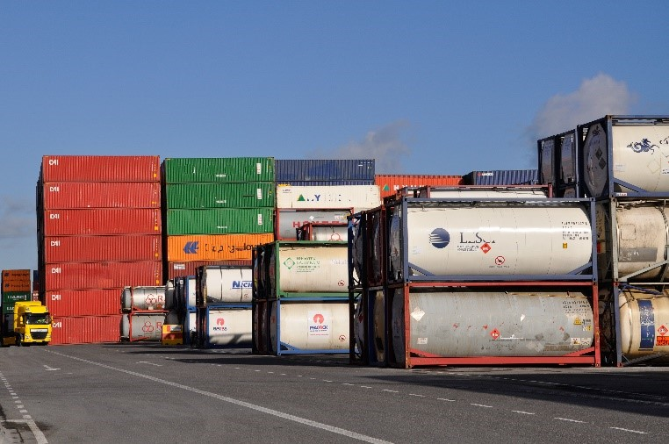
Figure 3 - Tank containers (front) and box containers (back)

Box Containers
The recommendations for joint storage can be neglected if
- packed hazardous substances in closed freight containers are in transit (kept ready for transport), between modes of, or
- the closed freight containers are not stacked vertically or placed directly next to each other. In that case, all applicable regulations on the carriage of dangerous goods such as ADR, RID, ADN or IMDG as well as national transport regulations are to be observed. This recommendation might be complied with if, for example, the minimum distance between the ITUs is 0.5 m in all directions (see TRGS 510⁴).

Measures for Segregation
If there is an increased risk (see sections 3.1.1 to 3.1.4) one should take suitable measures to create an effective segregation.
The definition of the measures should be done in a risk assessment considering the products, their specific properties the existing infrastructure and the internal and external emergency response. The results of this assessment should be documented. National regulations like TRGS 510⁴ or PGS 15⁵ can support this assessment.
Possible measures could be:
- the depot can be sectioned by fire-proof walls.
sufficient free space between the product containers depending on risk of the product and in line with local legislation (this distance can be used for storage of non-hazardous and non-combustible goods/ substances/ products. These substances must be assigned to storage classes 12 or 13).
- the retention basins of the separated areas can be divided.

Container Stacking
In general, it highly depends on the type of container, its load status and additional weather circumstances how containers can be stacked in a safe manner.
It is important, in first instance, to determine the type of container which needs to be stored. The following types of ITU are commonly used:
- 20’ ISO tank container
- Swap body tank containers
- 30’ and 40’ containers which are possibly high cube containers
- Open top containers

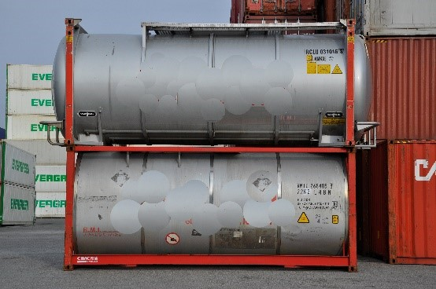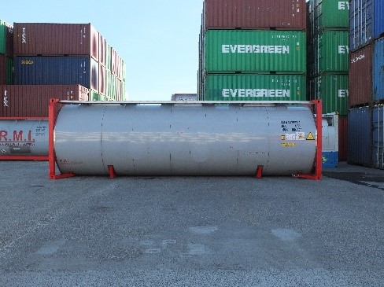
Figure 4 - swap body (top) and 20’ tank container Figure 5 - 40’ tank container

Depending on their status, whether the containers are empty or full, the maximum stacking height can vary. It is not recommended to mix normal containers and high cube containers.
When stacking containers, there remains a small possibility, that containers might fall from height. The main identified cause is heavy wind, potentially in connection with incorrect stacking. When falling from height, a container may rupture and set free its content, which in return may lead to further hazardous situations like pollution of the environment or the risks to expose people, depending on the nature of the product. In a worst case, people are hit by a falling container and suffer deadly injuries. In such a case, it makes no difference whether a falling container is loaded or empty.
When considering storing containers, the below tables might help to identify the stacking heights as far as not limited by local permits. However, it remains necessary to check the maximum stacking heights either in the container certificate of the involved containers or on the data plates attached to those containers. In advance, it is also important to observe whether the container corner castings of the containers that are intended to be stored are of the same dimensions and fit exactly on top of each other for the outmost stability and safety.

Table 7 - Guidance on maximum container stacking height for ISO Containers depending on whether empty or loaded and wind speed
 |  |  | 20’/ 30’/ 40’ ISO Container
 |  |  | En bloc |  | Single
BFT | Km/h | m/s | Loaded | Empty | Loaded | Empty
0 | < 1 | < 0.2 | 6 | 9 | 6 | 6
1 | 1-5 | 0.3-1.5 | 6 | 9 | 6 | 6
2 | 6-11 | 1.6-3.3 | 6 | 9 | 6 | 6
3 | 12-19 | 3.4-5.4 | 6 | 9 | 6 | 6
4 | 20-28 | 5.5-7.9 | 6 | 9 | 6 | 6
5 | 29-38 | 8.0-10.7 | 6 | 9 | 6 | 6
6 | 39-49 | 10.8-13.8 | 6 | 9 | 6 | 6
7 | 50-61 | 13.9-17.1 | 6 | 9 | 4 | 2
8 | 62-74 | 17.2-20.7 | 6 | 9 | 4 | 2

Table 8 - Guidance on maximum container stacking height for Swap Body Containers depending on whether empty or loaded and wind speed
 |  |  | Swap body
 |  |  | En bloc |  | Single
BFT | Km/h | m/s | Loaded | Empty | Loaded | Empty
0 | < 1 | < 0.2 | 3 | 9 | 3 | 6
1 | 1-5 | 0.3-1.5 | 3 | 9 | 3 | 6
2 | 6-11 | 1.6-3.3 | 3 | 9 | 3 | 6
3 | 12-19 | 3.4-5.4 | 3 | 9 | 3 | 6
4 | 20-28 | 5.5-7.9 | 3 | 9 | 3 | 6
5 | 29-38 | 8.0-10.7 | 3 | 9 | 3 | 6
6 | 39-49 | 10.8-13.8 | 3 | 9 | 3 | 6
7 | 50-61 | 13.9-17.1 | 3 | 9 | 2 | 2
8 | 62-74 | 17.2-20.7 | 3 | 9 | 2 | 2
BFT: Beaufort
Km/h: Wind speed in kilometers per hour
m/s: Wind speed in meter per second (commonly used by equipment manufacturers)

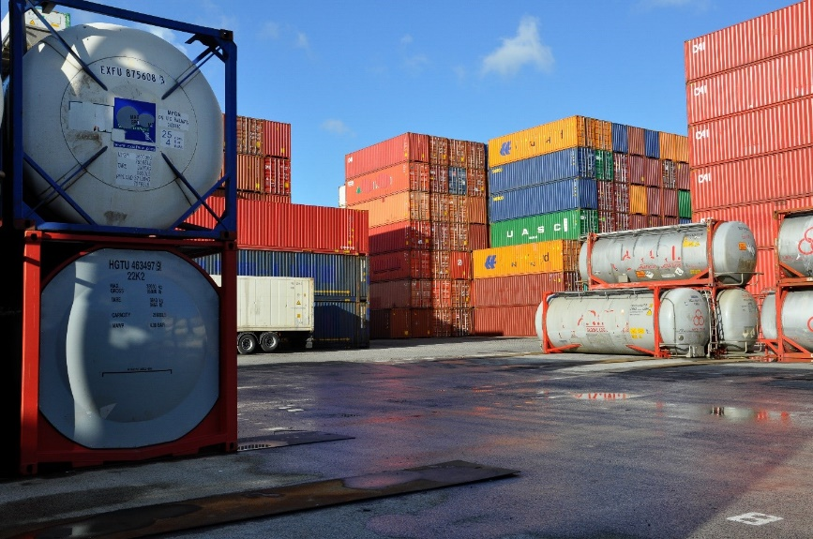
Figure 6 - Stacking of 20’tank containers (left), swap bodies (right) and block stacking of empty box containers (in the back)

Different construction types of containers to the ones addressed in the tables, like for example open top containers, require a separate assessment and need to be stacked according to the information of the container supplier.
Wind speeds of 9-12 BFT are excluded in the above tables. In such instances, the situation needs to be evaluated and adapted to on a case-by-case basis.
As shown below, containers can be stacked in so-called stairs during heavy-wind weather periods to provide a maximum stability.


Figure 7 - Schematic representation of a stair stacking of containers that should be more stable in high wind speed situations

To achieve the highest safety standard, connectors which are similar to twist locks, should be used between the upper and lower containers. This will prevent them from shifting at high wind speeds or an accidental streak by lifting equipment.
When building up a single stack of containers, it is important to think about the border of the terminal and the possible area in which tipping containers might fall. This area should be free of thoroughfare, buildings or other objects.

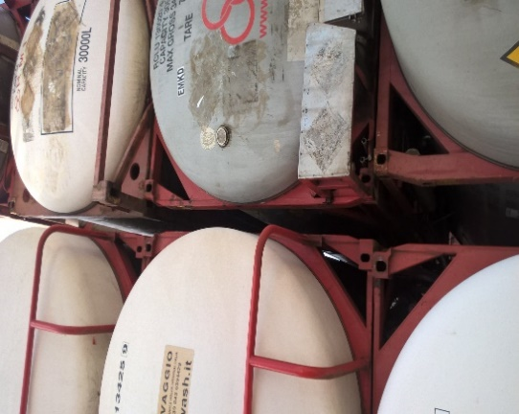

Figure 8 - Swap body tank containers are sometimes of such a design that it takes some skill and careful maneuvering to place the containers well on top of each other

In any case, it is strongly recommended to limit the access to any container storage area to authorized staff only. It is also advised to monitor and to use preventive actions for the main cause which may lead to containers falling from height e.g. the wind, depending on its strength. In the following, the adequate technical and organizational preventive measures are described as well as the corrective actions if available.
The installation of a wind meter on the tank container terminal helps to monitor the actual wind strength and its development during working hours.
From an organizational point of view, working procedures need to be in place containing the above information about the maximum wind below which safe working is still possible. Ideally, these maximum wind speeds are agreed upon with the respective hardware suppliers for containers, reach stackers and cranes. In addition, the working procedures inform about how to stack containers, meaning, that containers are not piled up in single towers but are stacked in blocks to provide more stability against high wind speeds. This includes information about how many containers shall be stacked on top of each other and how they are placed on the container terminal. Ideally, all employees are trained accordingly during a toolbox meeting by a qualified internal or external person. These working procedures need to be distributed and signed for acknowledgement by the involved and affected employees.

Flooring
As containers are usually stored on the ground it is important, that there is adequate flooring. This has three main reasons:
- On the one hand, in the case that a product spill takes place, the ground water could be contaminated with negative effects for the environment and people.
- On the other hand, potholes or uneven flooring can lead to accidents caused by lifting and driving equipment, like for example reach stackers or trucks when colliding with stored containers, or if individuals slip or trip.
- Of course, it is also evident that piling up containers on uneven ground may cause that containers are falling from height.
In order to avoid environmental pollution as well as accidents with moving equipment and people, the following preventive and corrective measures are presented, from a technical as well as from an organizational point of view.

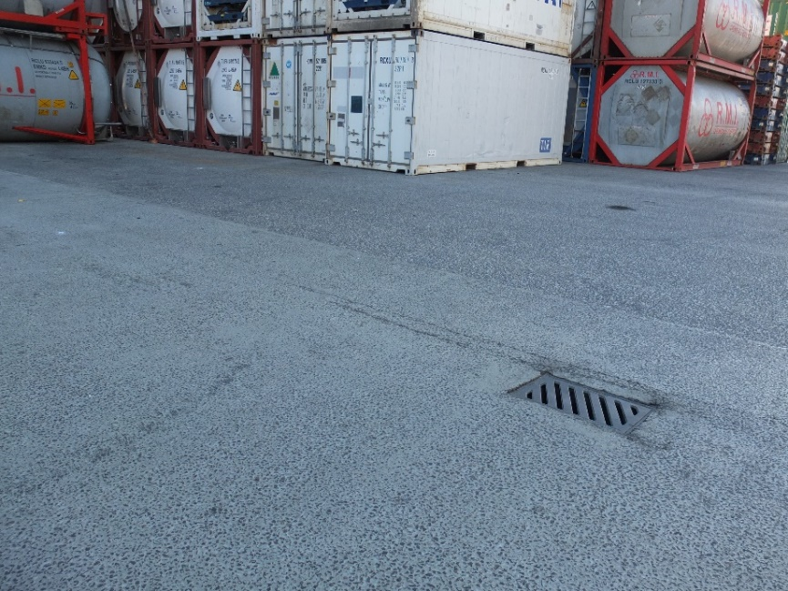
Figure 9 - Containers on a liquid tight floor

Ideally, the flooring is liquid proof, tested and certified by an independent body and has the relevant maintenance proof. Regular maintenance and repair work guarantees an even surface and helps to avoid accidents. In order to detect insufficient flooring, a working procedure needs to be in place, which organizes regular inspection rounds and regular maintenance intervals.
If potholes or bad flooring are detected, it is necessary to mark off the affected area and to execute the relevant repair works with suitable building materials within a reasonable period of time.

Equipment
As already mentioned in the introduction, studies on incidents in container terminals show that equipment-related incidents harbor the biggest safety risk in day-to-day operations. Therefore, special emphasis must be put on the correct equipment selection, maintenance and staff training.

Equipment Selection and Specification
Machinery frequently used in container yards includes both moving and lifting equipment. Typically, terminal trucks, empty handlers, reach stackers and cranes are deployed.
The subsequent chapter lines out the recommended technical features as well as inspection and maintenance requirements.

Moving Equipment

Terminal Tractors and Tractor-Trailer
Terminal tractors, sometimes also known as spotter trucks are widely used for internal transport of loaded and empty chassis on container facilities. They usually boast a single-person cab and a shorter wheelbase than road trucks, often with a fixed mounted rear axle. Additionally, they are fitted with a fifth-wheel coupling with an integrated lifting mechanism.

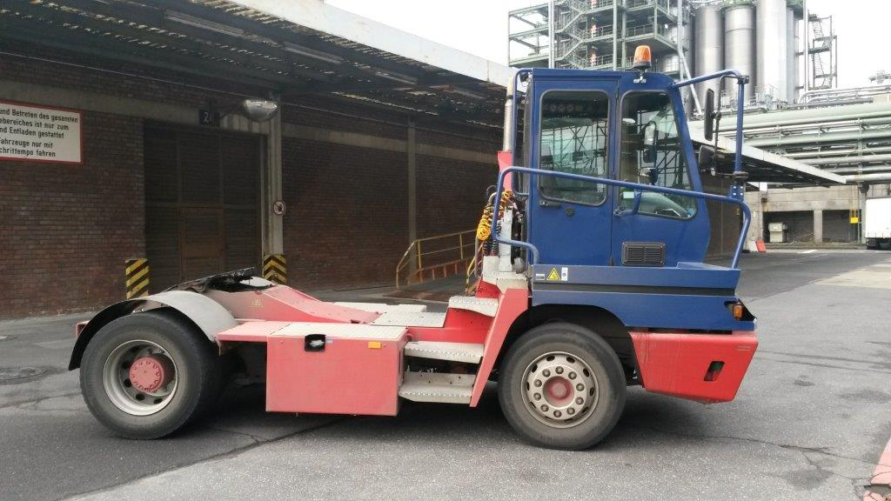
Figure 10 - Terminal tractor

The top speed of terminal tractors should technically be limited to 30 km/h, although terminal operators of course can choose to lower the maximum speed organizationally by signs or similar. Moreover, a driver restraint system should be available.
Additionally, a safe access to trailer connections must be ensured. This can either be achieved by a rear door from the drivers cab or a safe ascent via suitable steps and handles.

Chassis
Chassis may not show structural damage and should boast an under-run protection and proper lighting. Tires should have a minimum tread depth of 3mm and two wheel chocks should be carried. If the chassis are moved faster than walking speed (6 km/h), compressed air connections should be used to ensure sufficient braking action. Un-braked vehicles may be used in walking speed only.
For enhanced visibility of parked chassis, fitting with reflectors/ cat eyes or high-visibility tape should be considered.
For chassis used within the yard premises only, road approval as well as the certificate of approval in accordance to ADR 9.1.3 are not required.
If chassis without road approval are used, a documented internal system of controls must be in place.

Other Vehicles
All other vehicles which may be deployed in a terminal such as company cars or similar should be fitted at least with
- Head rests (all seats)
- Airbags (at least for the driver)
- Driver and passenger side-mirrors
- Anti-lock brakes
- Seat belts (preferably three-point, all seats)
Loose items can cause severe injury and shouldn’t be carried unsecured in the passenger compartment of any vehicle. Hence, cargo stowage devices should be provided were equipment has to be transported on a regular basis.

Lifting Equipment

Mobile Lifting Equipment
Large forklifts or lift trucks, reach stacker and empty-handler are the most common used mobile lifting devices in small and medium sized container terminals. They all boast good freedom of maneuvering which facilitates accurate positioning at stacking.
Lifting, lowering and telescoping are usually controlled by a hydraulic system. Other functions are enabled by an electric system.

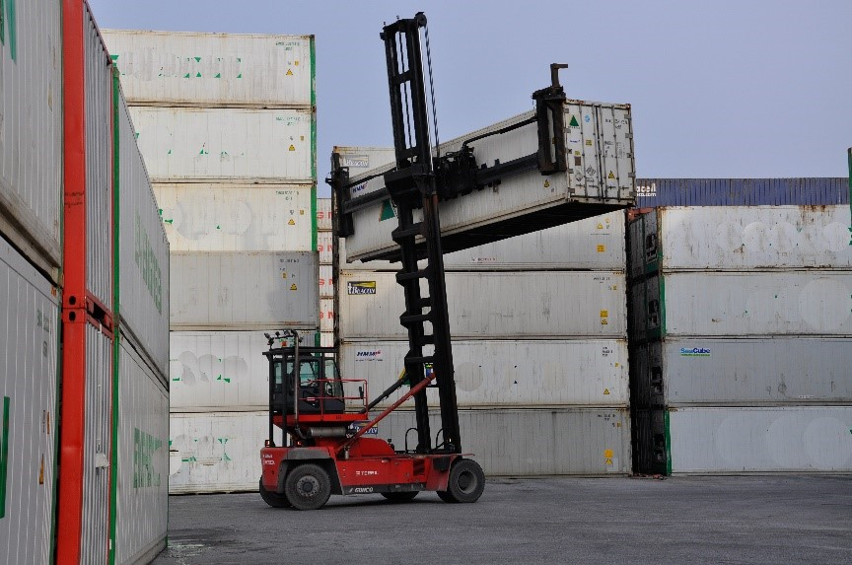
Figure 11 - Empty handler
Preferably, lifting devices should be fitted with basic status indicators of which a twist lock indicator is particularly valuable. Just as moving equipment, mobile lifting equipment is required to have both active lighting and reflecting elements.

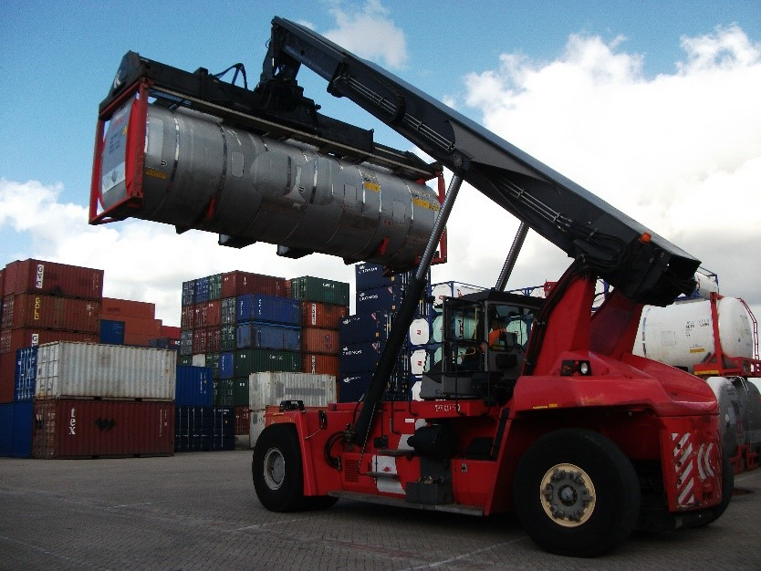
Figure 12 - Reach stacker (for loaded containers)
There is a possibility of roll-over if mobile lifting devices are handled improperly. In order to prevent such disaster, machinery with fail-safe functions are recommended. Such equipment will automatically stop operation before overturning can occur or if loads are tackled which are heavier than the maximum permissible weight.
Furthermore, it should be considered fitting vehicles with limited rear sight with a reversing audio alarm system.
Regarding personal requirements, training and written assignment of staff operating (mobile) lifting equipment, please see section 5.2.2.

Cranes
Both rubber tired gantry cranes (RTG) and rail mounted gantry cranes (RMG) can be found in container yards. In any case, all deployed cranes should be fitted with an automatic safe load indicator that functions properly. Both RTG and RMG cranes should be equipped with wheel guards.

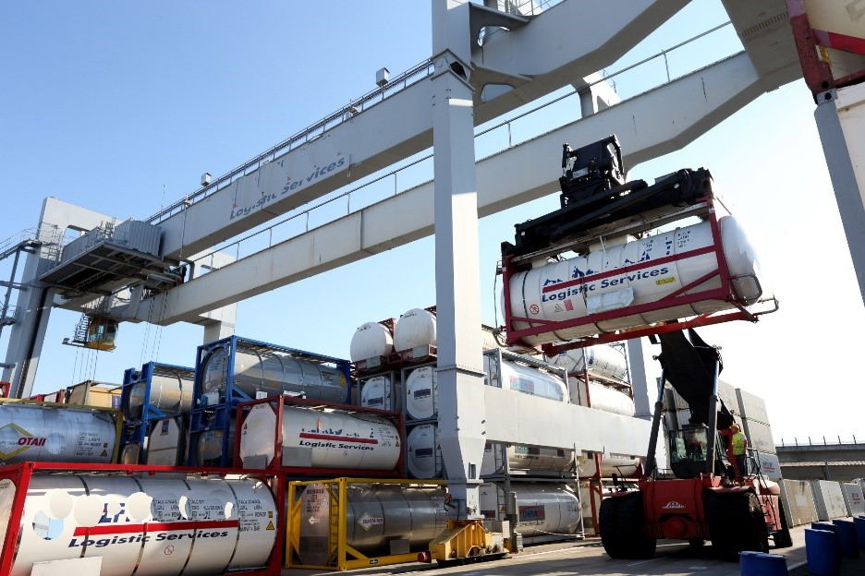
Figure 13 - Rail mounted gantry crane (RMG)
The chosen spreader must be suitable for the container types the terminal intends to handle. A safety device should be available which signals when the gantry crane is travelling.
Using gantry cranes commonly requires working at height. Technical prerequisites for safe workplaces therefore comprise anti-slip steps and adequate handles.
Alternatively, to an operation from a steering cabin, gantry cranes can also be operated from the ground by means of a radio remote control, facilitating the communication with the truck driver. Regardless which control system is chosen, all control levers should be clearly marked. The safe working load of equipment should also be clearly displayed.

Inspection and Maintenance of Equipment
To ensure mechanical equipment can be safely operated, machinery must be frequently checked, inspected and properly maintained.
Vehicles or similar having safety-critical defects are to be taken out of use immediately and must not be used until malfunctions are rectified. To identify machinery as “out of service”, it should be clearly marked e.g. with a sign.

Pre-Start Checks
A basic pre-start check is to be conducted on a daily basis by the staff member who is the first to use the equipment. It is to be conducted in good light, so that potential faults or defects are not missed. This obligation applies for both lifting and moving equipment.
Exemplary checklists defining the proposed extend of inspection for vehicles, lifting equipment and cranes can be found in Appendix 4 of this guideline. A general documentation of the daily pre-start checks is not mandatory, yet should be considered on a case-by-case basis.

Periodic Inspection
All equipment deployed must undergo a periodic inspection by a certified or competent inspector. If legal requirements or the manufacturer’s specifications do not state otherwise, the recommended test cycle is once per year. Date, name and signature of the inspector as well as the findings of the periodic maintenance are to be documented.

Container Operations

Internal Transport and On-Site Traffic
Transport-related accidents in container terminals have the potential to be serious or even fatal. As staff from different companies need to work together on the limited space of a yard, it is imperative to ensure a proper traffic way design and to implement an on-site traffic regulation scheme.

Layout of Traffic Ways
Container storage, loading and unloading areas as well as driveways and pedestrian pathways should be separated where practical to do so. This may result in excluding pedestrians from certain areas. Additionally, safe traffic way design is characterized by sufficiently wide passages and avoidance of difficult roads.
If overhead electric lines are present on the container yard, specific security measures are needed to prevent flashovers into large machinery such as reach stackers. The terminal proprietor should reach out to the power company in charge for the overhead line to work out the exact safety requirements.

On-Site Traffic Regulations
Drivers have to be familiar with the road rules on the site premises. Therefore, the traffic rules applicable within the site should be clearly displayed at each gate entry. To facilitate working in an international environment, icons should be the preferred mean of communication.

Table 9 - Overview of typical traffic signs on a container terminal
 | Provisions for increased  traffic safety | Measures and  additional information
Seatbelts   | All vehicles (owned, contracted or rented) should fitted with seatbelts for each occupant. The use of devices that stop, loosen or modify the proper functioning of seatbelts must be forbidden. | Three-Point seatbelts are to be preferred.  Drivers and passengers of any vehicle must use seatbelts at all times the vehicle is in motion.  Regular controls should be conducted, ensuring that the seatbelt is also worn during short distances, e.g. from one building to another. That goes also for light vehicles like company cars.
Passengers   | Drivers must not accept passengers unless authorized.
Mobile phones and similar   | Use of hand-held mobile phones when driving a vehicle is prohibited.  This includes text messaging. | Hands-free devices are permissible, but their usage should be limited as much as possible. Some sites have completely banned the use of phones while driving.
Media players and similar   | Use of audible earphones such as audio/ radio players must be prohibited. | This goes also for pedestrians while still being on site.
High Visibility Vests   | Every individual must wear a high-visibility vest when moving outside. | This includes visitors.
Speed   | A maximum speed of 30 km/h should never been exceeded within plant premises.  When specific site conditions apply, e.g. narrow spots, blind corners, the speed should be reduced further. | In case that lower maximum speed requirements are given, e.g. in chemical plants, these regulations prevail.  Maximum speed while reversing: walking speed  Maximum speed while entering or leaving blind spots or similar: walking speed
Parking  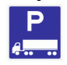 | Parking/ drivers rest areas must be clearly designated, signed and distanced away from main routes and dangerous areas.  No sleeping under or around parked vehicles.  Every effort should be made to park the vehicle in a way that the first move is forward. | If sufficient space is available, the parking spaces can be designed in a way that makes shunting unnecessary.  If space is limited, vehicles should be required to reverse into designated parking bays and move forward when leaving the parking space.

Permanent danger zones such as single steps or other trip-hazards, low passage clearances or similar obstacles should be marked black and yellow. Short-termed danger zones such as construction sites should be secured properly and marked red and white.

Safe Handling

Loading, Unloading and Lifting Operations
Poorly planned or conducted lifting operations can lead to significant hazards such as falling loads. Therefore, the following safe handling recommendations should be followed at all times:
- No person should be allowed to stand or pass under suspended loads.
- Mechanical equipment must not be used to handle loads greater than their safe working capacity.
- Only container handling attachments authorized by the manufacturer may be installed to the equipment.
- Operators must immediately stop working and report to supervisors if a major malfunction is found or a warning device is not operational.
- Containers should generally be lifted with suitable equipment which applies a vertical force to the four top corner fittings. Though this is dispensable for empty containers, the hoisting of a container at four corners is especially important for handling loaded containers of 20 feet or more.
- Lifting containers with forklift trucks or front loaders with side lift attachments is allowed only if both container and machinery are designed for such purpose.
- Under no circumstances should containers be lifted by forks in a way that the tank container shell has to bear the container load.
- A container should be lifted off the chassis only when it is ensured that the twist locks are disengaged.
- In case the operator does not have a clear and unrestricted view, operation is to be stopped and only summoned only with a suitable signaler.
- When operating a gantry crane, the container should be raised to a height were collision with already stored containers is prevented before starting to travel.
- To avoid a possible damage, containers must not be dragged or pushed over any surface.

Qualification of Personnel
Operators of lifting equipment must be at least 18 years old, unless national regulations have deviating provisions. Before assuming work, the operator has to undergo a medical check-up ensuring a good capacity to see (spatial vision, field of vision, mesopic vision) and hear. If national regulations or the medical expert do not state shorter time periods, this medical check-up should be refreshed every three years. Furthermore, equipment operators need to be trained in both theory and practice. The training should be completed with an examination, the results need to be documented. Additionally, new employees need to receive a comprehensive instruction on the equipment used in the specific terminal, even if they have a wide range of professional experience. Any operator handling lifting equipment needs a written assignment from the management attesting which equipment may be used by this specific staff member.

Unattended Machinery
When it is necessary to leave equipment unattended, the subsequent safety precautions should apply.
For vehicles and chassis:
- Engine turned off
- Brakes applied
- Ignition keys removed and driving cabinets locked
- If the vehicle is on an incline, the wheels should be blocked with appropriate wheel chocks.
For mobile lifting devices additionally:
- Lifting devices should be lowered and retreated as far as possible.
For gantry cranes:
- Spreader should be raised to its topmost position and measures must be taken to prevent unauthorized access or disengaging.

Safe Coupling and Uncoupling of Equipment
Each year, numerous accidents occur during shunting and coupling activities. Unfortunately, those incidents often result in very serious injuries or even fatalities. The root causes are in most cases misjudgment of the danger and thoughtlessness. Therefore, operators of shunting vehicles have to take extreme care when coupling or uncoupling vehicles. Ensure that nobody is within the risk zone between the vehicles, directly next to and behind it. The employee must have full visual control over the working area. Additionally, it has to be regarded that shunting vehicle and chassis are standing on firm ground before coupling activities are started.

Inspection and Maintenance of Containers
During inspection, repair and maintenance of containers, especially, but not only, when working on heights on top or inside of them, unsafe situations might occur. The prevailing risk when working on top of a container is that individuals may fall down and suffer from severe or even fatal injuries. The main risk when working inside a container is, that individuals suffocate. In extreme cases also members of rescue teams suffocate when attempting to help the first victim. Such an area is also known as confined space. Confined spaces generally describe locations with limited access points, which is not suitable for human beings to exist or live.
In order to avoid that people get injured or possibly suffer death, the following preventive and corrective measures are recommended, from a technical as well as from an organizational point of view.
When accessing the top of containers, it is important, that the involved individuals wear fall protection. Ideally, this fall protection consists of an installation on height to which any person can connect to while wearing a vest. It is paramount, that the fall protection is not attached to the container itself, which otherwise could lead to additional injuries when falling. This also refers to the ladder when climbing on top of the container. In addition, PPE like protective shoes, tight closing and helmet are a must.
Generally, it is not recommended to enter containers due to the high risk of suffocation. However, if necessary, any individual needs a special safety and risk awareness instruction as well as proper safety equipment like an oxygen meter, LEL detector or PID or, ideally, enough air in a self-contained breathing or stationary system. If a self-contained breathing system is used the person should have received a proper training to do so. In addition, the container needs to be ventilated through manlid and bottom valve.
For safety reasons it is necessary that at least a second person is present when any other person enters into a confined space in order to monitor the situation and to be able to intervene quickly in case of any incident.
Working procedures need to be in place, which regulate the occasion, proper type and correct use of PPE when entering containers or when working on top of them. Also the inspection of PPE and additional safety regulations like two-man-approach need to be described and communicated to the staff which is involved in such work. Trainings and toolbox meetings need to be documented and repeated regularly in order to maintain a high level of awareness and proficiency.

Heating of Containers
When storing tank containers with products having a relatively low melting point, it is often requested to heat the product so that it can be unloaded more easily. The depot can decide to offer this service, however, should take into account the risks that are attached to this activity.

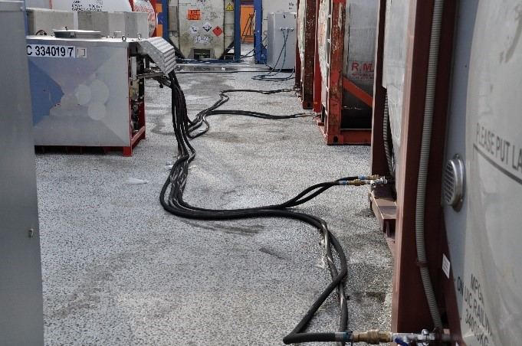
Figure 14 - Containers connected to a heating unit

The following methods are used to heat products in tank containers:
- by entering a hot medium (water, Glycol, etc.) through the steam coils of the container
- by entering steam through the steam coils
- by plugging in an electric heating system that is attached to the container.
For this activity, the following measures have to be considered:

Product Evaluation
In order to be able to perform an adequate product evaluation the depot holder should acquire the knowledge (chemical and physical) about the characteristics of the product when heating. The Safety Data Sheet is the primary source of information about the risks attached to the product. More knowledge can be obtained from the producer of the material or from a chemical specialist.
Additionally, the customer/ producer of the product should be asked about the possible effects and risks that can occur when heating the product. Special attention should be paid for example to products that present a risk of polymerization or other internal reactions that can generate pressure build up in the container or an explosion. The necessity of creating an ATEX zone should be considered. Similar attention should be paid to the possibility of toxic fumes being formed when the container is being heated as well as the risk of overflow because of product expansion. A special problem could be the reheating of solidified or frozen products with stabilizers, like acrylic acid. Due to different melting points, the stabilizer could be accumulated in the inner core of the container. After reheating, the stabilizer is not homogenized in the liquid and polymerization might occur.

Control of Steam/ Water/ Glycol Pressure
Steam coils of tank containers have a maximum allowable working pressure (MAWP) that has to be respected. This MAWP is noted next to these steam coils and can also be read from the test certificate of the container. Overpressure can lead to leaking steam coils which can result in spillage or even contamination of the product inside the container. Devices are available that can regulate the amount of pressure of the steam.

Glycol/ Water Temperature
The water/ Glycol temperature should be monitored to be able to manage the product heating process. There are systems available that allow the temperature to be monitored from a distance. The maximum allowable contact temperature should be respected to preserve the product quality.

Product Temperature
The product temperature has to be monitored closely during the process. This can be done by physical checks, performing rounds and reading the external thermometer on the container. It should be considered though that the reading of that device does not give necessarily the correct temperature of the product. The temperature level will mostly not be evenly spread inside the product.
A dipstick thermometer can only be used under the condition that contamination can be prevented, safety of staff can be guaranteed and with consent of product owner. The chemical properties of the product must be taken into account. Measurement might be done at several points inside the tank.
Also, the permission of the customer should be obtained to break the concealment before this operation can be executed. The proper PPE should be used and the dipstick should be entered by the air inlet of the container rather than the manhole to minimize the release of fumes and the risk of contamination of the product. If possible, a link between the temperature measurement system and the functioning of the heating system could be created. In this way the whole process can be automated.

Overflow
Before connecting the container to the heating system, a check should be performed to make sure that the product expansion that occurs during the heating will not lead to a spillage. This check should be best performed by taking into account the actual volume of the tank (container) which can be found on the data plate and the loaded volume which is marked on the transport document.

Heating Plan
When the product characteristics have been evaluated and the risks attached to the operation have been assessed, a heating plan can be drawn up. This plan should include the following elements, if applicable:
- Heating medium (water, Glycol, steam, electricity)
- Heating location
- On chassis/ not on chassis
- Means of temperature measurement
- Maximum steam pressure
- Frequency of monitoring
- Approval breaking of concealment
- Protective equipment/ clothes to be used
- Temperature of heating medium to be set
- Maximum contact temperature of the product
- End temperature of the product
- Handling of seals on the container (replace yes/no)

Sample Taking
First of all, the site should have the policy that sampling of containers should be prevented. However, when there is still a strong need for sampling, the site should have a procedure in place.
Hazards that can occur are:
- contamination of staff or third parties
- environmental pollution (air, water, soil)
- safety and/or quality issues of the product (impurities, reaction with moisture/ atmospheric oxygen)
- working on heights (transport of sampling equipment and risk of falling).
If the permit allows, the sampling should be performed by authorized experts, using proper equipment, for taking and transporting samples. For choosing the correct personal protective equipment, the latest version of the SDS should be available. The use of a permit to work, including a risk assessment, is strongly recommended. The risk assessment will help identifying which equipment and procedure is the most suitable to carry out the work safely.
For working on heights, use of secure fencing at all sides of the walkway on the container or mobile gantries can be used. The last resort for falling protection is the use of personal fall restraint systems. In that case also a recovery plan for the person hanging in his/her equipment should be in place to avoid suspension trauma.
A guideline on Working on Heights can be found at the Cefic website.

Transferring Material into another Container
Sometimes, in case of an emergency like a leaking container, the product has to be transferred into another tank container or tank truck. Since this activity has to be usually done in a state of urgency it should be ensured that the process is well prepared in advance.
Depending on local circumstances the following steps need to be taken:
- Place container on spill containment facility
- Inform the authorities
- Contact the owner of the product
- Choose the best way of transfer (pump, compressed air, Nitrogen, freefall)
- Organize a receiving loading compartment (tank truck, tank container)
- Select professional technical support to perform the transfer
- Develop a Transfer Plan in which all steps have been risk assessed

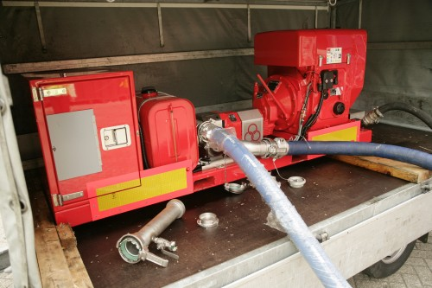
Figure 15 - Pump, running on diesel (no sparks), for chemical liquids

The Transfer Plan can be made by the technical support service and should list all risks involved in the activity. The following elements should be reviewed before the operation:
- Transfer method in relation to the product related risks like flammability, explosion hazard, accumulation of static electricity, product quality
- Possibility to break seals - should be approved by the product owner
- Risk of vapors entering the environment - vapor return method is preferable
- Volume of receiving compartment (application of 80-20 rule)
- Cleanliness of receiving compartment
- Suitability of receiving compartment (ADR/ IMDG/ weight restrictions)
- Necessity of persons/ services to be present (e.g. local authority, fire brigade, depot supervisor, etc.)
- Presence of a safety data sheet of the product
- Clarity about who is technically responsible for the operation
- Presence of hoses that are suitable, clean and pressure tested
- Making sure that vehicles are immobilized
- Spill containment method (liquid tight floor, sewer cover, etc.)
- Presence of suitable personal protective equipment
- Possibility of earthing
- Presence of suitable connection pieces
- Presence of correct (ADR) labels
- Availability of necessary fall arrest system
- Sufficient lighting
Best practice is to use a checklist, making sure no elements are being forgotten.

Emergency Response & Spill Preparedness
While section 2 to 5 describe in particular barriers that will prevent an incident from happening, a container terminal should also prepare for the situation that one or more of these barriers fail. In such a situation, the terminal management and staff should be able to act fast and adequate and limit the impact to people, environment and the surrounding of the terminal. To this end, the terminal should assess the potential risks and consequences of the products and activities on site as for example generically described in the Appendix 1 - Model Container Terminal Risk Assessment. The terminal should use this assessment to develop/ maintain an Emergency Response & Spill Preparedness Plan, which should be reviewed every three years and address relevant credible scenarios such as:
a. Spills
b. Exposure of People
c. Fire and Explosion
d. Natural Disasters
Based on these scenarios the Emergency Response Plan & Spill Preparedness Plan should identify those resources that will be used to handle the various scenarios. In case third parties, like fire brigade or a local Mutual Aid Scheme, are part of the identified resources, they need to be well aware of the local situation. Terminal staff that might be involved in the (first) response should be well trained in that response, the Personal Protective Equipment (PPE), other emergency response equipment they need to use and the hazards of the chemicals that might be involved. The Emergency Response & Spill Preparedness Plan should contain a plan to test its contents on a regular basis, preferentially in conjunction with those third party resources that have been identified in the Plan.

Spills
Emergency procedures will have to be initiated in case product is spilled from a container. As this harbors the risk that people are exposed to hazardous material and/or the environment is polluted, the terminal should have both the knowledge and the means to response in an adequate way.

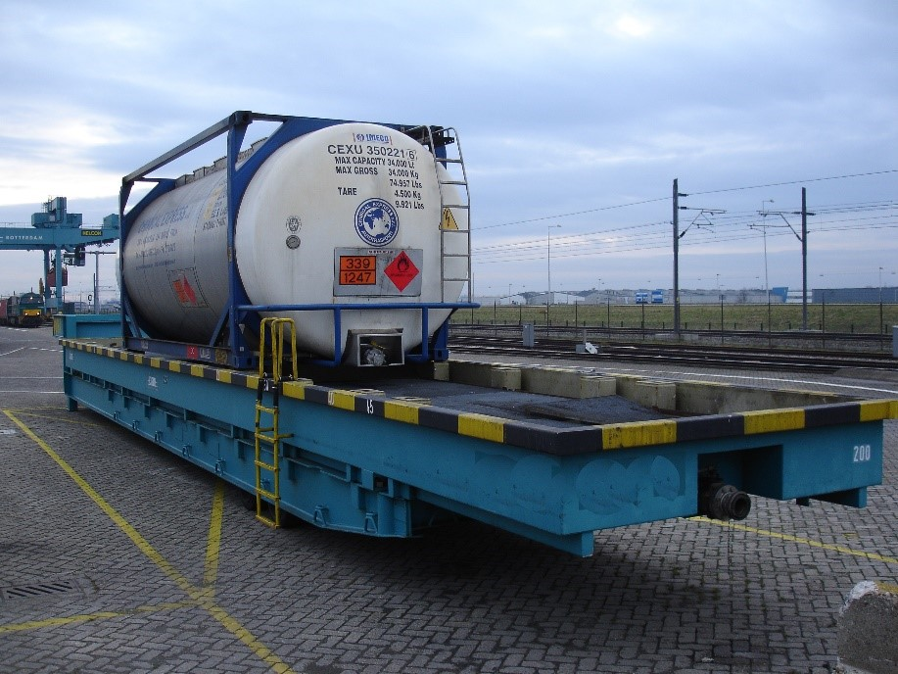
Figure 16 - Movable drip tray

There are two types of spills: small, dripping ‘leakages’, which are often the result of insufficient closing of valves or manholes; and large, uncontrolled product loss that occurs when the tank shell is ruptured. As a damage to the tank shell might be a result of handling activities, such as falling down from a spreader or hitting other equipment, it is preferable that a second appropriate lifting vehicle is readily available.

Small Spills - Dripping
Small spills should be discovered during the check-in of the container or during inspection rounds. These rounds can be supported by gas detection (for example in a terminal with flammable liquids or gases). Level indicators in the pump sump can also support a fast detection of spills. If a leakage is detected, the container should be immediately moved to a spill containment facility, like a container drip tray. These should be adequately dimensioned to receive all container types handled by the terminal. It has to be movable and has to be placed on a dedicated emergency area. The area should be outside the normal traffic routes and distanced from other stored products, offices, open water, housing, or other hazardous conditions. The emergency area should be fitted with an impermeable floor, readily available absorption material, an emergency shower and potentially firefighting equipment. Rainwater has to be purged from the drip tray on a regular basis to make sure that the receiving capacity stays intact and because some products may react dangerously with water. A stationary supply point for electric power (EX-installation), sufficient fire water supply and emergency showers can be helpful for the emergency response teams.
For smaller spills, an amount of adsorbent material should also be stored near to the container stacking area.

Large Spills
When handling (tank) containers, there remains the small the risk that it falls from the stacking equipment resulting in a large spill. Though it is unlikely that a tank container completely bursts open in such scenario, the worst case is any damage creating a hole in the tank shell. To avoid contamination of the ground, the terminal operator has to store the containers on a liquid tight floor as specified in section 3.3. Also, the spilled product, and in addition the water or foam that may be used during the emergency response, should be contained on the site. For that purpose, a reception facility should be created on the site. While the size of this facility should be based on a risk assessment it is common in industry to use 10% of the total amount of stored product or at least the biggest single hold up (for example one tank container) + 5 cm for rain water as a starting point. For flammable products, an additional hold up of 30 cm over the total area of the retention basin is recommended for fire extinguishing foam to cover the basin in a case of an emergency.
The retention basin should be resistant for all products handled on site.
To avoid that the spill remains underneath the containers, it is recommended that the retention basin has a downward slope to the side of the basin and ideally, a collection ditch at that side. Such a design might reduce the risk of contaminating other containers or of a pool fire underneath the containers. An even higher level of safety can be achieved, if the product retention basin is connected with a storage area that is separated from the container. In such a situation, the chance on a pool fire in the container area is strongly reduced. In addition, the amount of foam necessary is lower, because the basin can be build deeper and thus can store the same quantity with smaller surface.
On top of that, the risk that contaminated material enters into the local rain water evacuation system should be addressed, as well as the risk that it contaminates the local drinking water supply by entering the sewer system. In practice, this means that in case of a large spill it should be possible to redirect, manually or semi-automatically, the flow of waste water from the normal evacuation system to the buffer capacity. Covers for the gullies, stored near to the gullies can also be very helpful for the spill control. All these requirements should be integrated in the design of the facility.

Exposure of People
Although the risks on the site should be as much as possible addressed at the source, it cannot be excluded that people are exposed to residual risks (see Appendix 1 - Model Container Terminal Risk Assessment). As a consequence, additional measures (e.g. PPE) should be in place to address these. The standard PPE for people on container storage part of the site should be helmets, safety shoes and safety clothing. If flammable products are used on site, working garments should be fire retarding. While addressing a spill, fire or explosion, very specific PPE will be required.
Inspection rounds are a key activity in maintaining the site safe. Intrinsically to the activity, the inspection people might observe a leakage and therefore have a higher risk of exposure. Moreover, while being between large rows of stacked containers, the area, with limited ventilation, limited escape possibilities and oversight, might be similarly treated as confined spaces. Therefore, depending on local circumstances, stacking height and products stored, inspection rounds should be considered to be treated as entries into confined spaces, and consequently in that case, inspection staff should:
- Have a gas mask with carbon filter suitable for the stored products with them for direct use
- Carry a personal gas detector sensitive to the products stored if product might be high risk upon exposure
- Have direct communication with the site operation room to request support
- Preferentially work in teams where one enters the stack row and one stay outside
Similarly, drivers of mobile equipment should have an escape mask at their hand in the cabin of their equipment. The site should train their staff on handling this type of situations in their emergency response training (see intro to chapter 6). This also means that the site should have a procedure for use, inspection and replacement of the carbon canisters.
Emergency showers and eye showers should be placed in close proximity to the working areas where spills and contamination can occur. They have to be checked for function regularly, should be well signposted and frost free.
Depending on the products stored the site should consider putting fixed gas detection in place to detect flammable, explosive and toxic gasses and vapors. Having a wind vane will help people understand where to go in case of a gas alarm. To address such a situation, the site should have an evacuation plan in place. As part of the plan, the site should have:
- training of staff and those facilitating an evacuation
- preassigned muster places based on the most likely emergency situations
- a process to account for all people at the muster stations
- a process to prevent emergency entrance and exit to be blocked
- people and equipment other than related to emergency response should be prevented from entering the site in case of an emergency
The site should ensure that critical emergency response equipment is not stored downstream the prevailing wind direction of containers that can produce these gasses and vapors.
If there is a risk that people outside the site might be exposed, immediate action will be needed, involving communication to the affected neighborhood. In case the authorities have arrived on site, this will normally be their responsibility. If they did not (yet) arrive on site or do not want to take responsibility, Site Management will have to initiate that communication and the site should have a plan how to do so. Transparent communication with the neighborhood prior to such an emergency might facilitate the response during an actual emergency.
To address simple wounds, first aiders and first aid kits should be present on site. However, the site should also be prepared to act when someone gets more seriously hurt. In particularly if this might be because of exposure due to non-common chemicals stored, the site should be prepared to pass on a SDS of the product to the medical doctor/ hospital.

Fire and Explosion
Next to the measures described in section 2 to 5, critical barriers to prevent the occurrence of a fire or explosion are, among others, an effective Work Permit system, a Hot Work procedure, defining ATEX zoning and an Open Fire procedure. Basically, the Work Permit system ensures that one or more selected people (Work Permit Issuer) keep an overview of all activities that take place in a defined area. This enables the Work Permit Issuer to assess how these activities might affect the risk of other operations conducted in that area. Work can only start with a signed permit from the Work Permit Issuer in charge. A Hot Work procedure ensures that sign-off takes place on critical activities like isolation of the equipment from its surrounding/ infrastructure, cleaning of the equipment, and gas detection before the hot work is started.
Having the product in a closed container, the likelihood of a fire or explosion is not very high as can be seen from the Model Container Terminal Risk Assessment in Appendix 1. Still, realistic scenarios are:
- A product release from the container and subsequent ignition.
- Once a pool fire has occurred, it might lead to pressurizing the content of this or other containers resulting in a Boiling Liquid Expanding Vapor Explosion (BLEVE). While the pressure inside the container becomes higher by the increasing temperature and the structure of the compartment weakens, the container could rupture resulting in a sudden product release. Presence of an ignition source might ignite the vapor.
Alternatively, the pool fire might locally heat up the container leading to a decomposition reaction or, depending whether there is oxygen in the gas cap, a fire auto-ignites.
- A reaction of the product in the container might lead to pressure build up and therefore potentially the container can burst. The reaction might take place because (a) the concentration of an inhibitor, that prevents that reaction from taking place, drops below a critical level, the reaction is triggered (b) by a contamination, e.g. rust particles, or (c) because an incompatible other material enters the container, e.g. water/ moisture when a sample was taken or the reactive product (e.g. an isocyanate) was loaded in a wet container. It might also happen if the inhibitor is not evenly distributed e.g. after solidification of the product by cold temperature even if the product is reheated.
To fight a fire with water or probable foam, the terminal should have a circular buried water supply line that is able to deliver at least 3600 l/min of water for 2h duration. For a depot with flammable products, the amount should increase to 5000 l/min due to the higher risk. If national regulations or the permit states a deviating water supply, these regulations prevail. The specific demand of fire water supply for each site is determined by the local emergency response authorities and should be discussed as part of a proper risk assessment with them. The distance between the fire hydrants should be not more than 100 m. If there are goods and/or installations between the hydrants, the distance between the hydrants should further reduced based on the risk assessment and the input from the authorities. Sufficient hand fire extinguisher (preferentially using extinguishing powder) should be distributed at places all over the terminal (e.g. near to the storage area, heating/ cooling stations and the area for trans-loading product between container). The firefighting equipment, including the fire hydrants, should be tested regularly in line with local regulations or the manufacturers’ recommendations, whichever is more stringent.
For the storage of flammable liquids with the danger of a pool fire, appropriate measures for a fast detection like gas detection, regularly patrols or fire detection systems and fixed emergency response measures like stationary or semi-stationary foam systems or unmanned water monitors could be considered. Additionally, unmanned water monitors can also have an important role in cooling a container with a reacting product, facilitating an effective emergency response and significantly reducing the risk of a BLEVE (Boiling Liquid Expanding Vapor Explosion).
As indicated in the spill section above, the terminal should have a facility to retain and collect the contaminated water/ foam from a fire fight and prevent any contamination of the environment. The extinguishing water/ foam will have to be retained at all times, independent whether the product is classified as harmful to the environment.
The amount of waste water/ foam that should be contained should be based on realistic emergency scenarios (fire and product spill) and agreed in close cooperation with the local emergency response unit. The assessment should take into account:
- the chosen response approach (e.g. firefighting, dissolving gases in water)
- the capabilities of the installation (e.g. pump and/or water performance)
- and the requirements of the emergency response organization (e.g. local position of the basin).
The size of the basin to collect waste water/ foam should be defined separately from the recommendation for spills above, but the same design recommendations are applicable. Obviously, the basin should also be resistant to the potentially used water/ foam combinations.
The size of the retention basin is linked to the measures of the emergency response (e.g. quantity of water per min) and local circumstances. Mobile retention systems (for example empty containers, separate basins, retention bags) which can be provided either by the terminal or by the emergency response team can be taken into account. In such case, it has to be considered that the appropriate connections (e.g. hoses, pipes, suitable pumps, and especial proper connectors) are available in the case of an emergency.
If there is a possibility on site, or by the emergency response teams of mobile retention systems (for example empty container, separate basins, retention bags), this can be taken into account. But using mobile solution needs consideration of appropriate, and in the case of an emergency, available connection (e.g. hoses, pipes, suitable pumps, and especial proper connectors).
Independent of construction details and size(s) of the retention system(s), there should be a possibility to close each connection to the public sewer system.

Natural Disasters/ Climatological and Geographical Risks
Climatological variances can have a large range of influences on the storage of containers. Possible risks are described in the next sections.

Temperature
The potential risk due to temperature variances, from very low temperatures to high temperatures, are related to development of under-pressure or high pressure in the container, with the results of implosion or bursting and subsequent environmental pollution.
The properties of the stored substance, especially when handling stabilized products, can contribute to the risks. During solidification, the inhibitor might not be homogeneously distributed anymore. When the product subsequently melts, areas might occur where the inhibitor levels are below the critical minimum concentration to be effective. A run-away reaction might be the consequence. Similarly, high temperatures might lead to reactions of the product. Information on critical temperatures can be found in the SDS or obtained from the supplier. To minimize these effects, sensitive goods should be stored in protected areas where available.
For controlling the temperature heating or cooling, if suitable for product and equipment, might be done after consulting the producer. (See also 5.4)

Flooding and Heavy Rain
During heavy rain, the storm drains can become overwhelmed and the site can be flooded. Especially after a long dry period. Contributing is the reduced absorbing ground at the storage area.
Floods can have a destructive power and have impact on the flooring, infrastructure of the site and leading to floating of containers, loss of containment and contamination of water. For storage of box containers with water-reactive substances, the contact with water might lead to the emission of flammable gases. This can subsequently lead to explosive mixtures with air, with all its consequences, and may endanger the human health and the environment. (See also 6.3)
In case flooding is a risk to consider, the use of dikes or portable systems to prevent high water from flooding the site might be effective barriers to protect the storage site.
For heavy rain, a drainage system for processing the rainwater using a drainage basin can prevent flooding. Moreover, in doing so the rainwater can be used as a resource, e.g. supply of water in case of the need for firefighting. A periodic maintenance and control system of the sewage system and drainages should be in place.
If in a sensitive area, implementing a procedure to monitor the weather forecast might help in preparing for flooding.

Abbreviations

ADR European Agreement concerning the International Carriage of Dangerous Goods by Road
A.D.N. European Agreement concerning the International Carriage of Dangerous Goods by Inland Waterways
BFT Beaufort (Wind speed)
BLEVE Boiling Liquid Expanding Vapor Explosion.
CAS Chemical Abstracts Service
CLP Classification, Labelling and Packaging (EU-directive 1272/2008)
DGSA Dangerous Goods Safety Advisor
GHS Globally Harmonized System of Classification and Labelling of Chemicals
HSE Health, Safety & Environment
IBC Intermediate Bulk Container
IMDG International Maritime Dangerous Goods
ITU Intermodal Transport Unit
LEL Lower Explosive Limit
LOC Loss of Containment
MAPP Major-Accident Prevention Policy
MAWP Maximum Allowable Working Pressure
MOC Management of Change
PGS Publication Series Hazardous Goods (Publicatiereeks Gevaarlijke Stoffen)
PID PhotoIonization Detector
PPE Personal Protective Equipment
RID Regulations concerning the International Transport of Dangerous Goods by Rail
RMG Rail Mounted Gantry Crane
RTG Rubber Tired Gantry Crane
SC Storage Class
SDS Safety Datasheet
SME Subject Matter Expert
SOP Standard Operating Procedure
TRGS Technical Rules for Hazardous Substances (Technischen Regeln für Gefahrstoffe)

APPENDICES

Appendix 1 - Model Container Terminal Risk Assessment

Appendix 2 - Container Segregation - Additional Information
Additional segregation information in relation to section 3.1.2.
- Self-reactive substances of hazard class 4.1 have properties comparable to those of the organic peroxides in storage class 4.1A or storage class 5.2 and must therefore likewise be assigned to these classes rather than to storage class 4.1B. Hazardous Substances of class 4.1 according to the dangerous goods legislation and which are not, for example, classified with R11 or H228 require a case-by-case analysis (for example sulphur, naphthalene, paraformaldehyde).
- All liquids that are not assigned to one of the storage classes 1 to 8 are assigned to storage class 10 (flammable liquids).
- Storage class 11 (flammable solids) covers solids that experience has shown to be combustible. Combustibility may also be determined by the assignment of a combustion class of 2, 3, 4 or 5 (at room temperature) as defined in VDI 2263 Part 1.
Examples:
  - Combustion class 2: Tartaric acid
  - Combustion class 3: Lactose
  - Combustion class 4: Tobacco
  - Combustion class 5: Metamizole
- Storage class 12 (non-combustible liquids) includes:
- liquid preparations containing ammonium nitrate in subgroups D I and D II of Annex I (5) to the Hazardous Goods Ordinance,
- liquids that are not combustible or with a low ignition tendency.
- Storage class 13 (non-combustible solids) includes solids that experience has shown not to be combustible and that do not meet the criteria of storage class 11. Combustion class 1 is assigned to substances such as table salt that do not burn in the determination according to VDI 2263 Part 1⁸.
- Storage classes 10 to 13 primarily relate to liquids and solids that do not require labelling under the dangerous goods legislation. They may also cover hazardous substances that are marked with the hazard symbols Xn, harmful; Xi, irritant; or N, dangerous to the environment, as well as solids or liquids classified as class 9 according to the dangerous goods legislation.
- The storage classes 10 to 13 can be summarized and then treated according to the joint-storage rules for storage class 11.

Appendix 3 - CEFIC/ ECTA HSSE Self-Assessment for Container Storage

Appendix 4 - Pre-Start Checklist for the inspection of Trucks used onsite.

CEFIC/ ECTA Issue Team on
Safe storage and handling of containers carrying dangerous goods and hazardous substances
 |  | 
Leo RUPERT  Global Advisor HSSE Shell Chemicals  Shell Chemicals Europe B.V.  Tel: +31 (0)10 441 62 92  leo.rupert@shell.com  Chairman of the Issue Team | Emilia POLJAKOV  Dangerous Goods Manager  ALFRED TALKE GmbH & Co. KG  Tel: +49 2233 599 434  emilia.poljakov@talke.com | Sabine SCHULTES  CHS-HSE Functional Lead Transport&Warehouse Safety  Bayer AG  Tel: +49 214 303 4234  sabine.schultes@bayer.com  Thomas STEEN  CHS-HSE Trainee  thomas.steen@bayer.com
 |  | 
Andreas SELLMEIER  Specialist Fire Prevention  BASF SE  Tel: +49 621 60-23335  andreas.sellmeier@basf.com | Philipp LUBCZYK  Senior Project Manager  Bertschi AG  Tel: +41 62 555 69 23  philipp.lubczyk@bertschi.com | Thorsten BAUER  Logistics Manager Logistics Safety  Evonik Industries AG  Tel: +49 2365 49-19470  thorsten.bauer@evonik.com
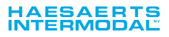 |  | 
Luc HAESAERTS  Director  Haesaerts Intermodal NV  Tel: +32 (0)3 860 64 64  lhaesaerts@haesaerts.be | Wolter STEIJN  Dangerous Goods Coordinator  LyondellBasell  Tel: +31 (0)10 275 57 94  wolter.steijn@lyondellbasell.com | Jan Hendrik LEOPOLD  SSHEQ Manager  RMI  Tel: +31 10 714 77 40  janhendrik.leopold@nl.rmi-global.com
 | 
Peng PATERNOSTRE  Transport & Logistics Manager  Cefic  Tel: +32 (0)2 676 73 72  ppa@cefic.be | Evert DE JONG  Responsible Care Director  ECTA  Tel: +31 6 53789 646  evert.dejong@ecta.com

Cefic Report - Intermodal Transport Network Development (2014)
Port Accidents are Avoidable Reports TT Club - July 2013, P. Emmanuel, Industry forum, ASEAN Ports and Shipping in Ho Chi Minh City, Vietnam (2013)
DIRECTIVE 2012/18/EU OF THE EUROPEAN PARLIAMENT AND OF THE COUNCIL of 4 July 2012 on the control of major-accident hazards involving dangerous substances.
https://www.baua.de/EN/Topics/Work-design/Hazardous-substances/pdf/TRGS-510.pdf?__blob=publicationFile&v=2
http://www.publicatiereeksgevaarlijkestoffen.nl/publicaties/PGS15.html
http://www.cefic.org/Documents/RESOURCES/Guidelines/Transport-and-Logistics/Best%20Practice%20Guidelines%20-%20General%20Guidelines/Guidelines-for-Managing-Change-in-a-Chemicals-Supply-Chain.docx
Best practice guidelines for safe working at height in the logistics supply chain, http://www.cefic.org/Industry-support/Transport--logistics/Best-Practice-Guidelines1/General-Guidelines-/
“VDI 2263 Part 1 - Dust fires and dust explosions; hazards, assessment, protective measures; test methods for the determination of the safety characteristic of dusts” http://www.vdi.de/gvc (1990)

